

**A Toolkit to Foster Mobile Crisis Intervention (MCI), School, and Caregiver Collaboration**

This toolkit was developed by the **Behavioral health Integrated Resources for Children Project (BIRCh)**, representing a collaboration between the University of Massachusetts Boston and the University of Massachusetts Amherst and funded by Boston Children’s Hospital.

The mission of the BIRCh Project is to provide professional development and resources for schools and strengthen the coordination of behavioral health supports provided by school and community agencies. More information is available at [www.umb.edu/birch](http://www.umb.edu/birch), or contact us at Birch.project@umb.edu.

***Authors:***

Amanda Priest, M.S.

Talia Berkman, M.Ed.

Kristina Ruggeri, M.S./CAGS, NCSP

Kathryn Kurtz, Ph.D., NCSP

***Acknowledgements*:**

Thank you to the many behavioral health providers, caregivers, researchers, and policy makers across Massachusetts who shared their expertise and experiences and made this toolkit possible.

**TABLE OF CONTENTS**

**Introduction** **2**

The Development of MCI Services in MA 3

Focus Group Analysis 7

Utilizing MCI Services in the School Setting 9

Frequently Asked Questions 11

**Setting the Foundation: MCI-School-Family Partnership** **12**

Guiding Principles 13

A Guide for Developing a Memorandum of Understanding (MOU) 15

Slide Deck: Mobile Crisis Intervention & School Collaboration 20

Inter-Agency Contact & Information Sheets 30

Sample Emergency Contact Form 36

**Pre-Crisis** **40**

Procedure Before Calling MCI 41

Preparing Materials & Space for Crisis 42

Teaming, Roles and Responsibilities 42

Communication Guidelines 44

**During Crisis** **46**

Encounter with MCI 47

School to Family Communication Script 50

Communication Guidelines 53

**Post-Crisis** **56**

Following up with MCI 57

Post-Crisis Reflection 58

Family Questionnaire 59

Communication Guidelines 63

**Suggested Resources** **65**

**References** **66**



# **Introduction**

* The Development of MCI Services in Massachusetts
* Focus Group Analysis
* Utilizing MCI Services in the School Setting
* Frequently Asked Questions (FAQ)

**Introduction to Mobile Crisis Intervention (MCI) and School Collaboration**

**Purpose:** This document introduces the development of MCI services in the state of Massachusetts through the Community Behavioral Health Centers (CBHCs). We provide an overview of the services offered through the CBHCs, examine what services look like across the country, describe major themes found in our focus group analysis of MCI and school collaboration, and describe the utilization of services in the school-setting.Our goal is to empower educators to partner with families and communities around these issues. Active hyper-links are embedded throughout the toolkit in the interest of integrating existing resources from across our state.

## The Development of MCI Services in MA

The timeline below highlights a few key events in Massachusetts history that led to the development of MCI services:

|  |  |
| --- | --- |
| **1963** | *Federal*: The **Community Mental Health Act** (Public Law 88-164) provided federal funding to support community mental health centers and related research. Five key services were targeted including emergency services, thus paving the way for the first mobile crisis programs. |
| **1975** | *Federal*: The Education for All Handicapped Children Act (Public Law 94-142) was signed into law by President Gerald Ford. Today, this law is known as the **Individuals with Disabilities Education Act (IDEA)**. To learn more about IDEA, visit: <https://sites.ed.gov/idea/> |
| **2001** | *Massachusetts*: A lawsuit was filed by the family of lead plaintiff, Rosie D., due to the lack of in-home services available for children with serious emotional disturbances. To learn more about the case of Rosie D., visit: <http://www.rosied.org/> |
| **2006** | *Massachusetts*: Judge Michael Posner issued a verdict in the case of Rosie D, in which he found the Commonwealth responsible. This decision led to the development of several services, including the **Children’s Behavioral Health Initiative (CBHI)**. |
| **2021** | *Federal:* The **American Rescue Plan** (Public **2021** Law 117-2) established Medicaid-funded options to provide community mobile crisis interventions (Section 9813), including planning grants to 20 states including Massachusetts. |
| **2023** | *Massachusetts:* As part of the **Roadmap for Behavioral Health Reform**, the state rolled out **Community Behavioral Health Centers (CBHCs)**. The centers provide a starting point for prompt, effective mental health and substance abuse treatment and offer 24/7 community-based crisis intervention as an alternative to hospital emergency rooms. |

**What are the CBHCs?**

Community Behavioral Health Centers (CBHCs) are one-stop shops for a wide range of mental health and substance use services and treatment. The statewide network of CBHCs includes 26 centers across Massachusetts that offer immediate, confidential care for mental health needs. Crisis services are available around the clock for anyone in Massachusetts who feels they may be experiencing a mental health crisis. This 24/7 in-person crisis support can be used by anyone in Massachusetts, whether or not they have health insurance. CBHCs also offer day-to-day mental health services for all MassHealth members, also covered by some commercial insurers.

**What services do CBHCs provide?**

*Mobile Crisis Intervention (MCI)* services are for anyone in Massachusetts experiencing a mental health or substance use crisis. MCI services are provided by trained professionals who can travel to your location or work with you at a CBHC to assess your needs, provide immediate assistance, and determine the best path forward. Instead of going to the ER, MCI services allow anyone going through a crisis to either walk into a CBHC or call for a team to come to their location and access immediate mental health care. Anyone can use MCI at any time, no insurance needed.

*Community Crisis Stabilization (CCS)* is a less restrictive alternative to inpatient hospitalization for people in need of short-term, overnight crisis care. The programs have home-like, friendly, and comfortable environments that offer a feeling of community while maintaining a safe and secure setting. CBHCs offer both Adult (18+) and Youth (18 and under) CCS programs with services including individual, group, and family therapy; medication management; crisis intervention; and future crisis prevention planning. CCS is covered by MassHealth plans and some commercial insurers.

*Routine Outpatient Services* are comprehensive outpatient mental health and substance use services for MassHealth members, also covered by some commercial insurers. These services are available every day of the week, both in-person at CBHCs and via telehealth, with extended hours. Services include same-day mental health and substance use evaluation, assessment, and individualized treatment; individual/family/group therapy; psychiatric medication consultations; peer support services; medication for addiction treatment; care coordination; referrals to treatment; and timely follow-up appointments.

**How can CBHC services be accessed?**

* Find your local CBHC: <https://www.mass.gov/community-behavioral-health-centers/locations>
* Here is a link to the Massachusetts Behavioral Health Partnership (MBHP) search form that helps patients identify behavioral health providers who can meet their unique needs: <https://www.masspartnership.com/member/FindBHProvider.aspx>
* Additional search forms to locate and access various mental health services across the state: <https://www.mabhaccess.com/MH.aspx>
* Utilize Network of Care Massachusetts, developed by the Massachusetts Association for Mental Health, which is an online searchable directory that can help you locate behavioral health treatments, services, and resources in your community: <https://massachusetts.networkofcare.org/mh/index.aspx>

**What is the Massachusetts Behavioral Health Roadmap?**

* The Massachusetts Behavioral Health Roadmap was developed by the Baker-Polito Administration. It is a multi-year plan that aims to provide more accessible treatment options, more effective treatment, and make strides toward health equity. The roadmap was developed with input provided from interviews and feedback shared from over seven-hundred collaborators.
* You can find answers to frequently asked questions about the Roadmap here: <https://www.mass.gov/info-details/roadmap-for-behavioral-health-reform-faqs>

**Do MCI services exist in other states?**

Yes! Most states across the country have one or more MCI programs. These programs are funded differently across the 50 states and some states have programs that explicitly collaborate with school districts, while others do not. We have highlighted a few of the programs on the following page to provide context:

|  |  |  |  |
| --- | --- | --- | --- |
| **State** | **Name of MCI Program** | **Funding Source** | **Resource(s) for Further Information** |
| **Alaska** | Crisis Now | State Department of Mental Health | <https://alaskamentalhealthtrust.org/alaska-mental-health-trust-authority/what-we-do/crisis-continuum-of-care/>  <https://alaskamentalhealthtrust.org/wp-content/uploads/2020/06/Core-Elements-One-Pagers_Core-Principles-and-Practices.pdf> |
| **Connecticut\*** | Action Line | State Department of Mental Health | <https://portal.ct.gov/DMHAS/Programs-and-Services/Finding-Services/Crisis-Services>  <https://www.mobilecrisisempsct.org/moa/> |
| **Florida** | Mobile Response Teams (MRTs) | State Department of Children and Families | <https://www.myflfamilies.com/service-programs/samh/publications/docs/Mobile%20Response%20Framework.pdf> |
| **Nebraska** | Youth Mobile Crisis Response (YMCR) | State Department of Mental Health | <https://scipnebraska.com/file_download/inline/db1f2e57-e523-409b-b76d-3c4b3c05b74d> |
| **Texas** | Mobile Crisis Outreach Teams | State Executive Office of Health and Human Services | <https://www.hhs.texas.gov/providers/behavioral-health-services-providers/crisis-service-providers/mobile-crisis-outreach-team>  <https://hhs.texas.gov/sites/default/files/documents/doing-business-with-hhs/provider-portal/behavioral-health-provider/community-mh-contracts/info-item-v.docx> |

*Connecticut has a Memorandum of Agreement (MOA) in place that several school districts within the state have signed. To our knowledge, Connecticut is the only state with Memorandums of Agreement (MOA) in place between mobile crisis providers and schools. An MOA is a legally binding agreement. If you are interested in reviewing the MOAs for the state of Connecticut, you can view these here: <https://www.mobilecrisisempsct.org/moa/>.

## Focus Group Analysis

Focus groups with MCI and school-based providers across Massachusetts revealed many strengths, barriers, and best practices about MCI-School collaboration.

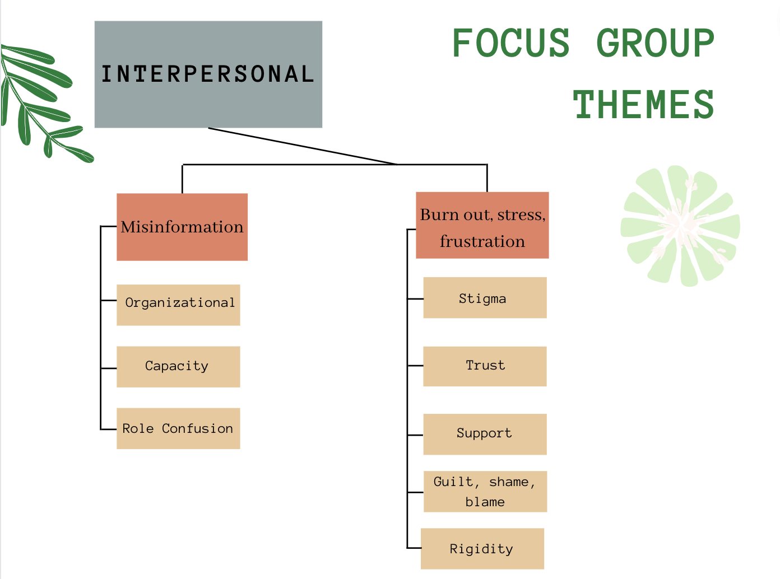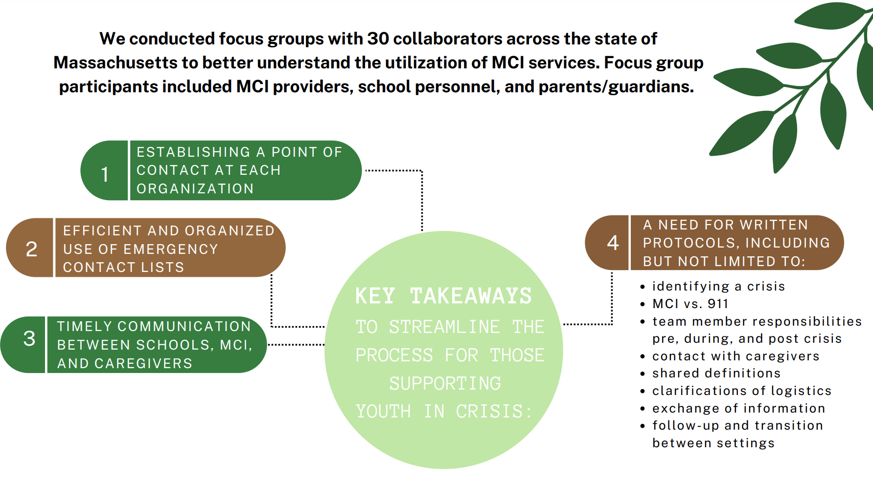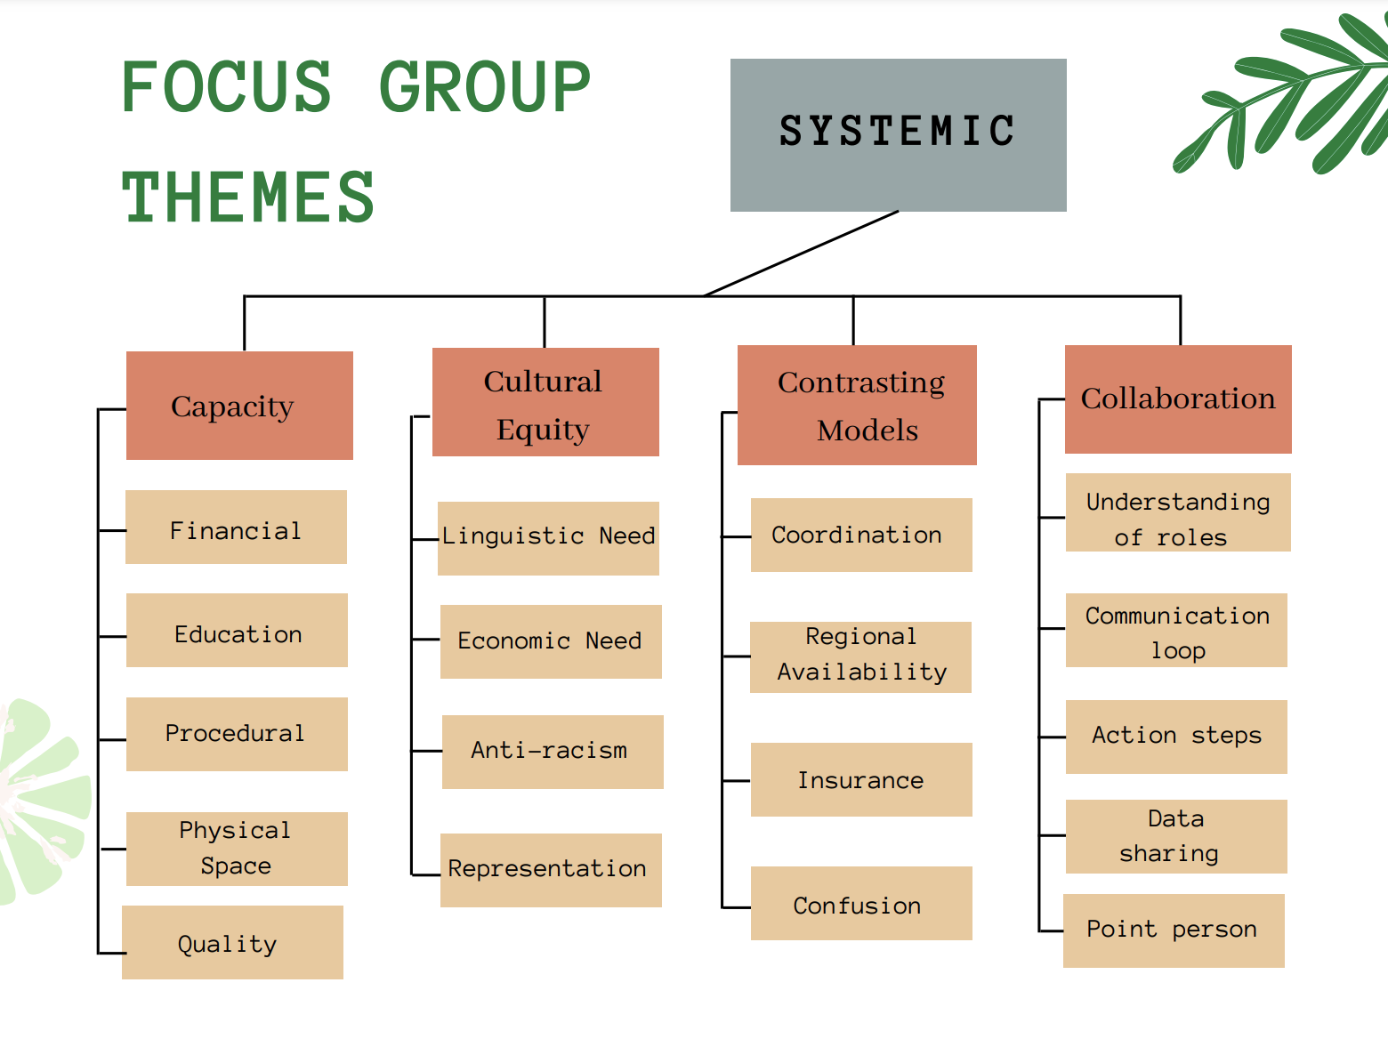

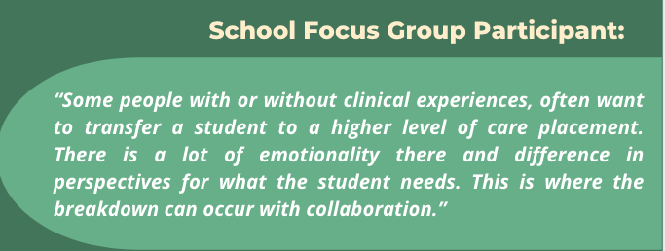

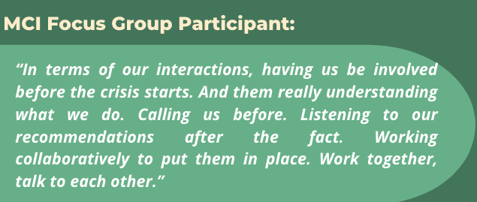

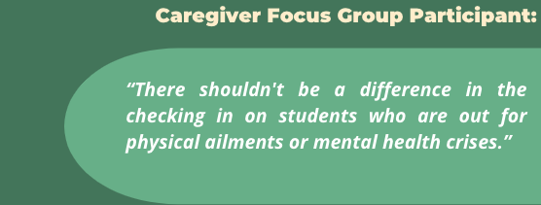

This focus group analysis was used to better understand current strengths and barriers of MCI-school collaboration. Findings were used to inform the development of this toolkit. First, a logic model was developed to frame the theory of change for improved MCI-School collaboration. As schools and community behavioral health providers have increasingly adopted a public health approach to service delivery, this toolkit should be considered within any existing Multi-Tiered Systems of Support frameworks (MTSS). MTSS is a framework in which services are delivered according to student need, including foundational practices to benefit all students and intensive support for students with the greatest needs. The logic model below was created to demonstrate steps that can be taken at each tier of service delivery and the impact of those steps.

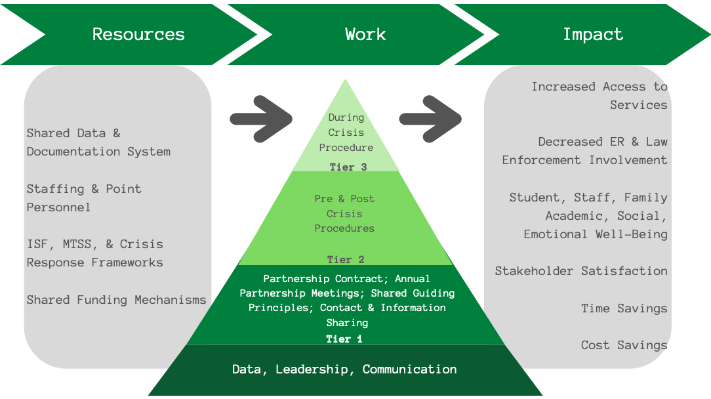

## Utilizing MCI Services in the School Setting

**How does MCI fit into a school’s existing crisis plan?**

Most schools have a crisis plan for responding to all types of emergencies that can arise in the school setting. MCI was designed to specifically support behavioral health crises. A behavioral health crisis, sometimes referred to as a mental health crisis, is “any situation in which a person’s behavior puts them at risk of hurting themselves or others and/or prevents them from being able to care for themselves or function effectively in the community” (NAMI, 2018). The terms behavioral health crisis and mental health crisis will be used interchangeably throughout this toolkit. MCI can be seen as an additional support for schools to access when crises occur that cannot be managed by the school crisis team alone. MCI providers are trained mental health professionals who meet the individual, often in the setting where the crisis is/has occurred. Their goals are to conduct an assessment and help the entire care team determine appropriate next steps for the person in crisis. MCI can provide stabilization, determine a plan, stay connected with the family up to a week following the crisis to offer support, make referrals, and foster continuity of care.

**Why utilize MCI services rather than referring a student to the emergency room?**

* Emergency department visits related to mental health have increased 24% for 5–11-year-olds and 31% for 12–17-year-olds between January and October of 2020 (Leeb et al., 2020).
* Schools are the source of up to 30% of pediatric psychiatric emergency room visits (many of them avoidable) (Soto et al., 2009), with 1 out of 10 school risk assessments leading to hospitalization (Crepeau-Hobson, 2013), and are crucial to emergency room diversion efforts.
* MCI services are defined by the rapid response (i.e., within 60 minutes) of a specially trained team (typically, composed of two people) in any setting, with the goal of crisis resolution, stabilization, and planning for the prevention of future crises (Shannahan & Fields, 2016).
* With the goal of stabilization, outcomes of MCI include minimization of police involvement and unnecessary use of force, appropriate utilization of emergency departments and hospitalization, cost savings, stigma reduction, care coordination between agencies, early identification and prevention of illness, and accessibility (Zealberg, Santos, & Fisher, 1993; Martin, 2005).
* Among youth, 40% of all mobile crisis referrals may be made from schools (Fendrich et al., 2018).

**Mobile Crisis Intervention (MCI) Frequently Asked Questions**

**What is MCI?**

MCI is a short term stabilization service for youth under the age of 21 experiencing a behavioral health crisis. They can provide onsite, face-to-face evaluation of the problem, assessment of the youth’s needs, and stabilization with the goal of reducing imminent risk of danger to the youth or others. MCI services are available 24/7.

**When should I contact MCI?**

You can contact the MCI team whenever you recognize that additional support is needed or if you need guidance determining if this is a crisis. This may even occur outside the context of a “crisis.” MCI providers can meet with caregivers to provide further education and support.

**How long will it take for MCI to arrive at my location?**

The goal of MCI is to arrive at the location within an hour of receiving a call. However, response times can vary day-to-day as they are dependent on service volume and geographical availability.

**Who is on the MCI team?**

The MCI team consists of a master’s level clinician and an additional support staff, typically a “family partner” (someone with lived experience of a mental health crisis or supporting a child with a mental health crisis).

**What does the MCI team’s assessment process look like?**

The MCI team evaluates the youth and may make recommendations and/or referrals to any behavioral health services that they determine to be appropriate for the youth. Additionally, the team provides follow-up support for up to 7 days following the encounter.

**Following the assessment, what is the MCI team’s role? What is the school’s role? Family/caregiver role?**

The MCI team is responsible for follow-up for up to 7 days following the initial encounter. The school is responsible for planning for the youth’s return to school and ensuring the youth has the support(s) they need. This process may involve collaborating with the MCI team and asking them for their recommendations on easing this transition. The family/caregiver(s) are responsible for following up with MCI and the school team to ensure that everyone is on the same page.

**How much does MCI cost?**MCI services are available to anyone for free in Massachusetts experiencing a mental health or substance use crisis regardless of insurance.



# Setting the Foundation: MCI-School-Family Partnership

* Guiding Principles
* A Guide for Developing a Memorandum of Understanding (MOU)
* Partnership Meeting Slide Deck
* Inter-agency Contact & Information Sheets
* Sample Emergency Contact Form
* Caregiver-School-MCI Communication Guidelines

## Guiding Principles

***MCI and School Teams***

**Purpose:** This section provides a detailed overview of a collaborative response to responding to students in crisis. We review guiding principles, recommendations for materials and physical space, team roles and responsibilities, and procedures to follow during a crisis.

*According to focus groups conducted in MA, caregivers, school providers, and mobile crisis providers all indicated a need for designating points of contacts at each organization, more efficient and organized use of emergency contact lists, and timely communications between schools, caregivers, and MCI. Providers highlighted the need for written protocols including but not limited to: identifying a crisis, when to call MCI vs. 911, who will call MCI, who will be in contact with caregivers, shared definitions between district and MCI, clarifications of logistics (i.e. space within the building), instructions for sharing of information, as well as guidelines for follow-up and re-entry support. To meet these needs, the BIRCh team developed this protocol to help guide a collaborative response to student crises among caregivers, school, and MCI providers.*

The following page illustrates the principles we hope will guide inter-agency collaboration.

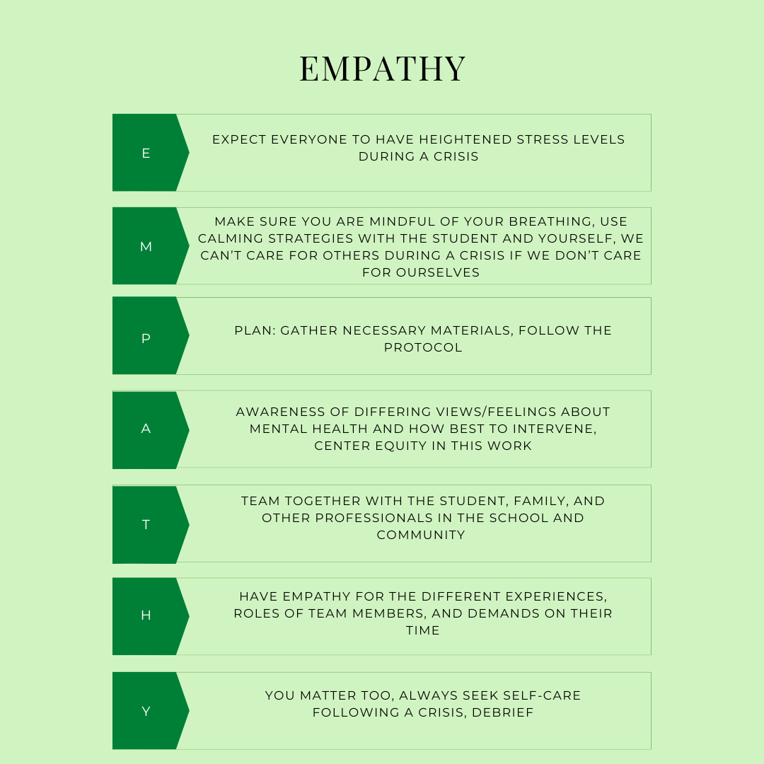

## A Guide for Developing a Memorandum of Understanding (MOU)

**Purpose:** A Memorandum of Understanding (MOU) is a non-legally binding written document that summarizes the agreement between two parties. This document details the responsibilities of each party and demonstrates the consultation and coordination needed to dictate these responsibilities. We will not be providing an MOU due to this being outside our scope of competence as psychologists. Instead, we will provide you with a detailed overview of the responsibilities involved in crisis management based on our research and discussions with collaborators. A Memorandum of *Understanding* (MOU) is not to be confused with a Memorandum of *Agreement* (MOA), which is a document that *is* legally binding. To our knowledge, the only state with Memorandums of Agreement (MOA) in place between mobile crisis providers and schools is Connecticut. If you are interested in reviewing the MOAs for the state of Connecticut, you can view these here: <https://www.mobilecrisisempsct.org/moa/>.

*Disclaimer: In reading this document, you understand that it is not an official MOU and should not be used as such. Use of this resource implies your acceptance of this disclaimer.*

**SECTION ONE: Expectations, Roles, and Responsibilities**

**Schools**

1. School leaders should review crisis team roles and responsibilities annually and adjust accordingly. Prior to the start of each academic year, any changes to the school crisis team’s composition and/or protocols should be clearly communicated to all school personnel. It is critical that everyone in the school be trained in the crisis protocol so all staff are accurately informed and able to respond to crises if needed (BCHNP, 2021). This includes paraprofessionals, librarians, cafeteria workers, office staff, custodians, substitutes, aides, etc.
2. Team member composition may include, but is not limited to, the following:
   1. Principal
   2. Assistant principal and/or dean(s)
   3. School psychologist(s)
   4. School social worker(s) and/or school adjustment counselor(s)
   5. Special education teachers
   6. School nurse(s)
   7. School Therapeutic Support Staff (Applied Behavior Analysis (ABA) specialists, outside agency therapists)
3. There should be a clear chain of command with designated roles and responsibilities for each team member.
4. Team member roles may include, but are not limited to, the following:
   1. Crisis Team Leader
   2. Crisis Team Co-Leader or Assistant Leader
   3. MCI Communication Liaison
   4. Family/Guardian Communication Liaison
   5. Student support personnel (can be one team member or alternating team members that have a strong relationship with the student)
   6. Regulation support staff
   7. Medical support staff

**MCI Providers**

1. The structure and protocols for MCI providers will vary from district to district. However, it would be beneficial if at least one person within the MCI agency could establish and maintain a connection with local schools.
2. The MCI team member responsible for school communication should establish a partnership with schools they will serve prior to the start of the academic year. The following items may be discussed (but will vary among MCI providers):
   1. Expectations for schools in regard to contacting MCI
   2. Information about the Health Insurance Portability and Accountability Act of 1996 (HIPAA) to create awareness about what information can and cannot be shared with school staff
   3. Information that schools can provide to the families and students they serve about MCI services, when and why MCI is contacted, the evaluation process, and the follow-up process

**SECTION TWO: Annual Collaboration Meeting**

The purpose of the annual collaboration meeting is to ensure all staff from both parties are clear about the nature of their partnership. Topics of discussion may include, but are not limited to, the following:

* Shared definitions between district and MCI (i.e., crisis assessment, crisis stabilization, non-violent crisis intervention, ESP provider, etc.)
* Private and safe spaces in the school buildings where crisis evaluations may take place
* The process of contacting caregivers and information to be communicated
* Response times for MCI and what causes delays
* Information about schools’ capacity to handle behavioral health crises
* Information schools can share with MCI to be most helpful- proactively, during crisis, as well as after the crisis
* When to contact MCI versus 911

In the spirit of collaborative partnership, we also recommend that MCI present once during the year to school staff and school staff present once during the year to the MCI team. Staff from each party have unique knowledge and training experiences in their respective fields. School staff could provide insight into their capacity to manage behavioral health crises based on financial and resource related factors (i.e., physical space, high student to staff ratios, knowledge of mental health challenges, etc.). MCI staff could provide training on supporting student mental health, responding to crises, de-escalation strategies, and so forth. Additionally, this would be an opportunity for each party to pose any questions or concerns that arose during the duration of their partnership thus far.

**SECTION THREE: Working with Caregivers**

**Confidentiality**

As mental health professionals, MCI providers are bound by HIPAA to maintain confidentiality for the youth they serve. HIPAA limits what health information can be shared with others and whom this information is shared with. However, teachers and other school staff are not bound by these same laws. This does not negate the importance of maintaining confidentiality (BCHNP, 2021). Families and youth experiencing behavioral health crises are often facing increased shame due to the stigma associated with mental illness. If school staff do not make an effort to protect student and family privacy, then it is highly likely that trust will be violated, negatively impacting the relationship.

**Notifying Caregiver of Crisis**

If the caregivers are not the ones to access crisis services, they should be notified immediately so they can be involved in the decision making process (BCHNP, 2021). The caregivers can provide school staff and crisis team members with critical information to inform the most appropriate steps to take. It is important to notify caregivers in a way that is respectful and clearly communicates the facts of the situation.

***Guidelines for Communication with Caregivers***

1. Remain mindful of the language used to communicate what has occurred (stick to the facts)
2. Avoid labeling the student’s behaviors

**DO:** “Jaden reported that he heard a voice telling him to hurt himself.”

**DON’T:** “Jaden seems to be experiencing psychotic symptoms. He is reporting auditory hallucinations.”

1. Be direct and name what the primary concerns are
   1. Let the caregiver(s) know that their child is safe but in need of support
   2. Ensure that you ask the caregiver(s) if they are in a private space and have time to talk
   3. Share behaviors that have been observed by staff
   4. Relay any thoughts or feelings that the child has communicated
   5. Report what school staff have done thus far to support the child
   6. Ask the caregiver(s) for their thoughts on the situation: *In hearing what is going on, does this seem new to you? Has your child experienced any of this before? What are your thoughts on the situation?*

*Do you have any ideas about how we can best support your child until*

*you arrive?*

* 1. Explain why you are contacting them and validate that you understand this is a disruption to their day, but you would not call unless you felt their child was truly at risk

**Cultural Considerations**

1. Remain mindful of the language you use in communicating with caregivers. Be cautious of labeling the event as a “mental health crisis.”
2. When designating a crisis team member to contact the family, be aware of language and/or communication needs. It may be necessary to find a translator or utilize assistive technology.
   1. It is beneficial if the person notifying the family already has an established, strong relationship and the capacity to be culturally sensitive.
3. If the caregiver(s) express concerns about calling crisis providers, offer to provide them with more detailed information and answer any questions they may have.
4. If you believe that emergency services may become involved, strongly consider each family’s unique circumstances and needs. This is especially important for BIPOC students and families safety and wellbeing.

***We have reviewed this document and agree to maintain this understanding amongst both parties. We recognize that this is not a legally binding agreement, but guidelines that will be used to maintain a strong collaborative partnership.***

____________________________________________________________________

School Crisis Team Lead Date

____________________________________________________________________

MCI Team Lead Date

____________________________________________________________________

District Administrator Date

## Slide Deck: Mobile Crisis Intervention & School Collaboration

*These slide decks are meant to help guide 1-2 annual partnership meetings per year between MCI and school-based providers. The goal of these meetings (and the provided slide decks) is to help strengthen the relationship between teams and work towards a common understanding of their shared work.*

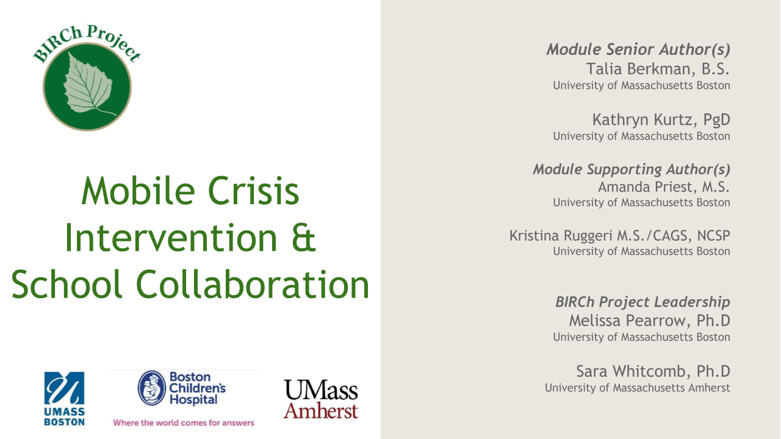

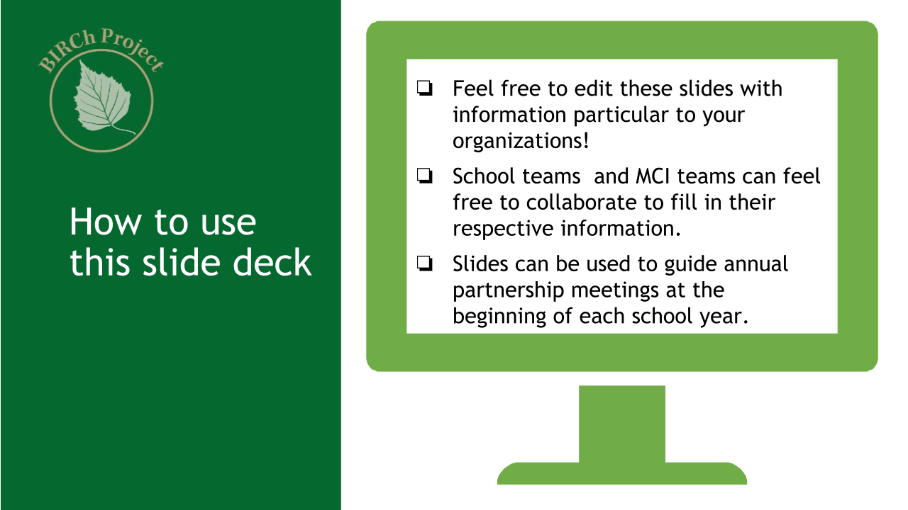

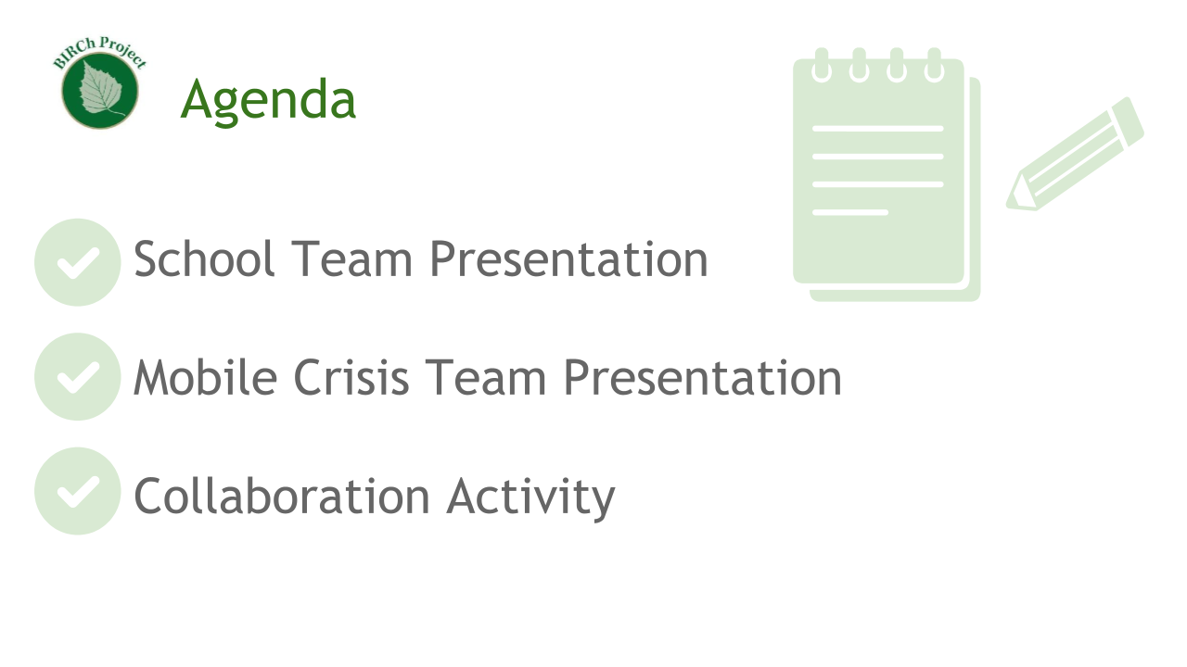

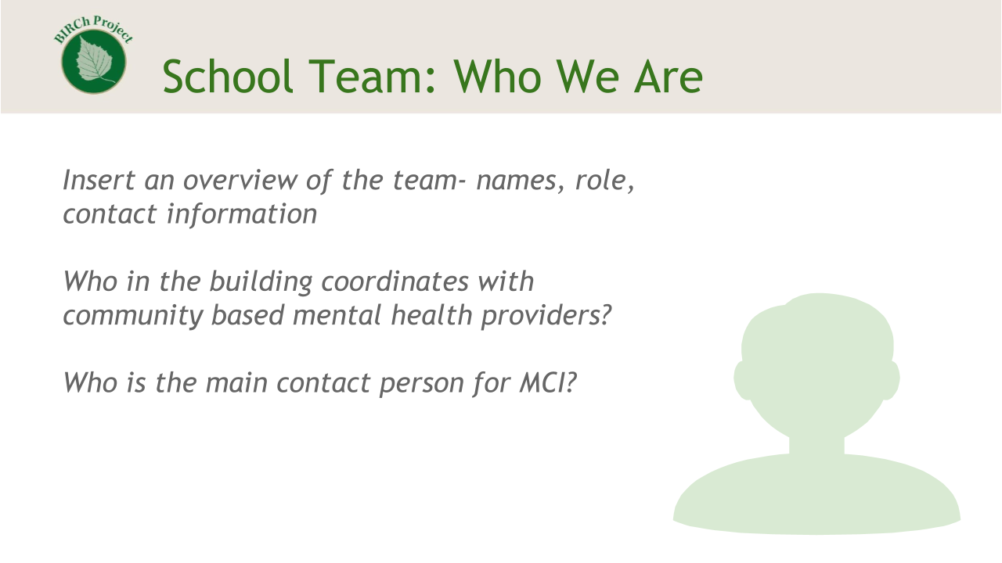

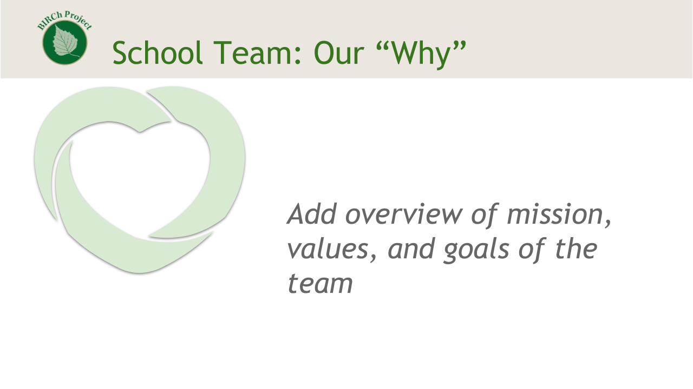

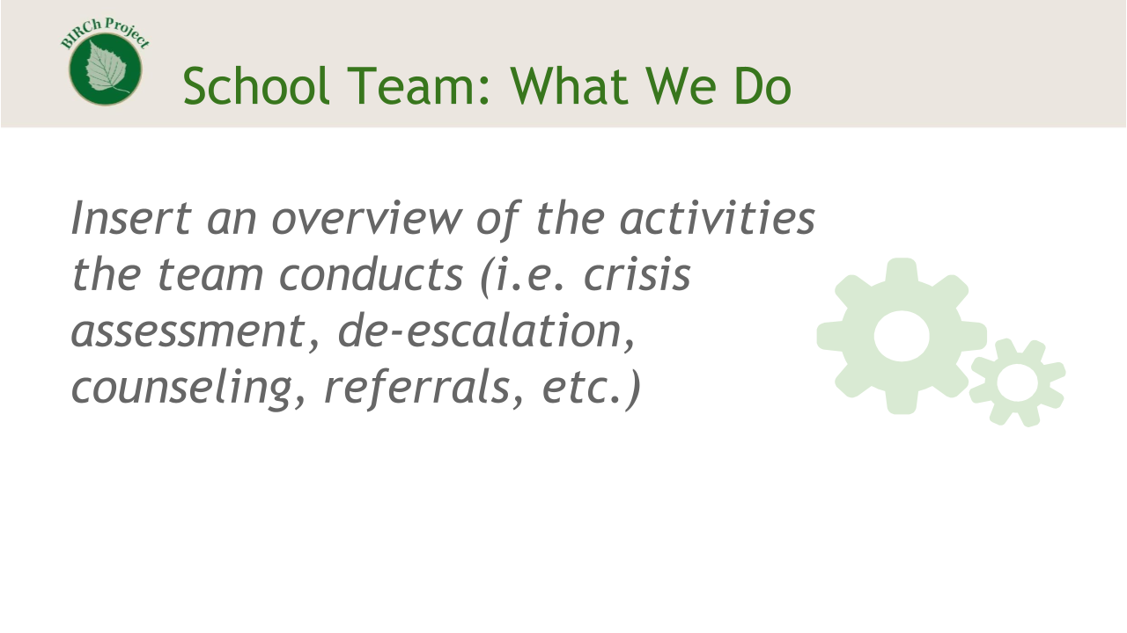

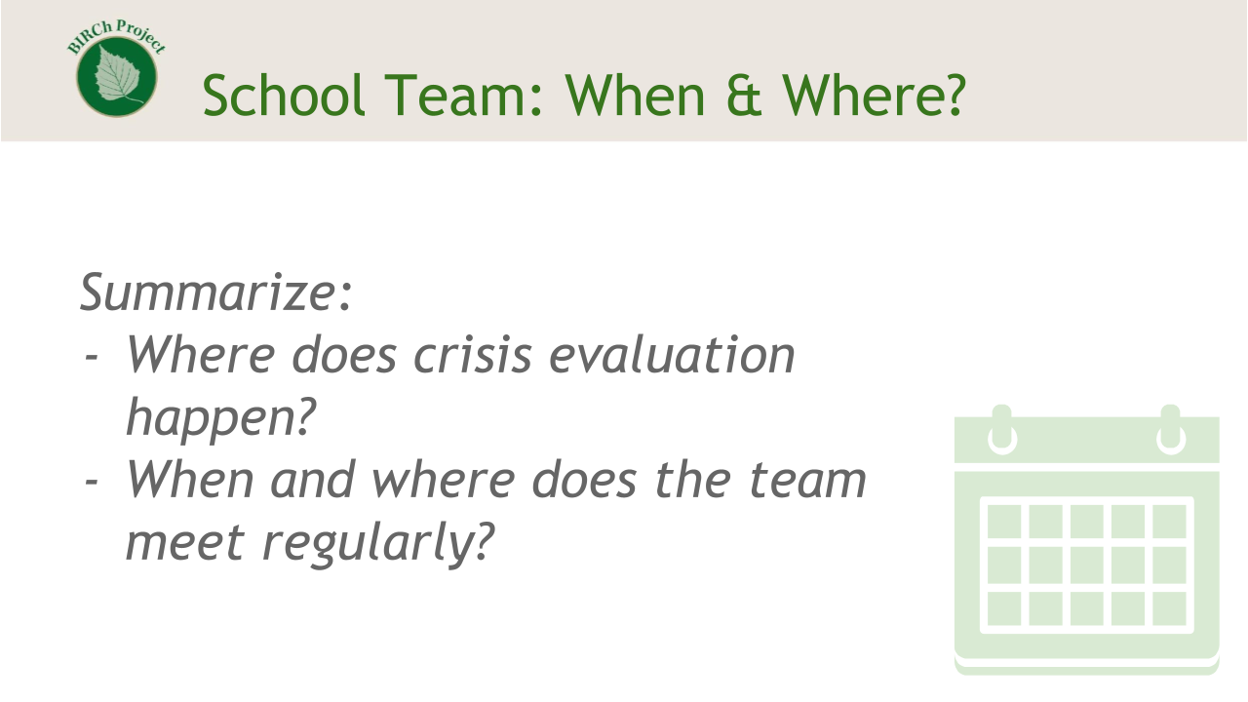

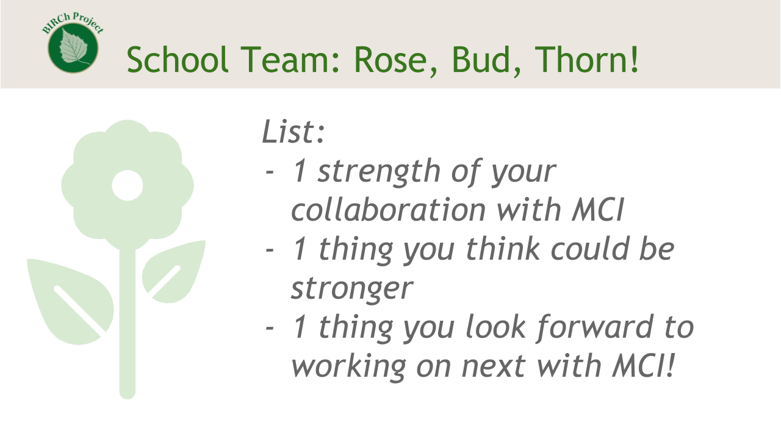

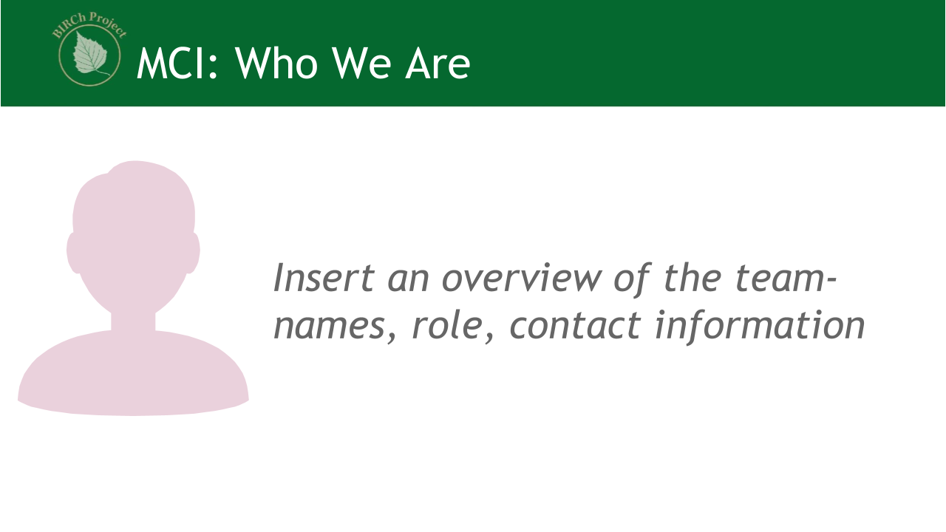

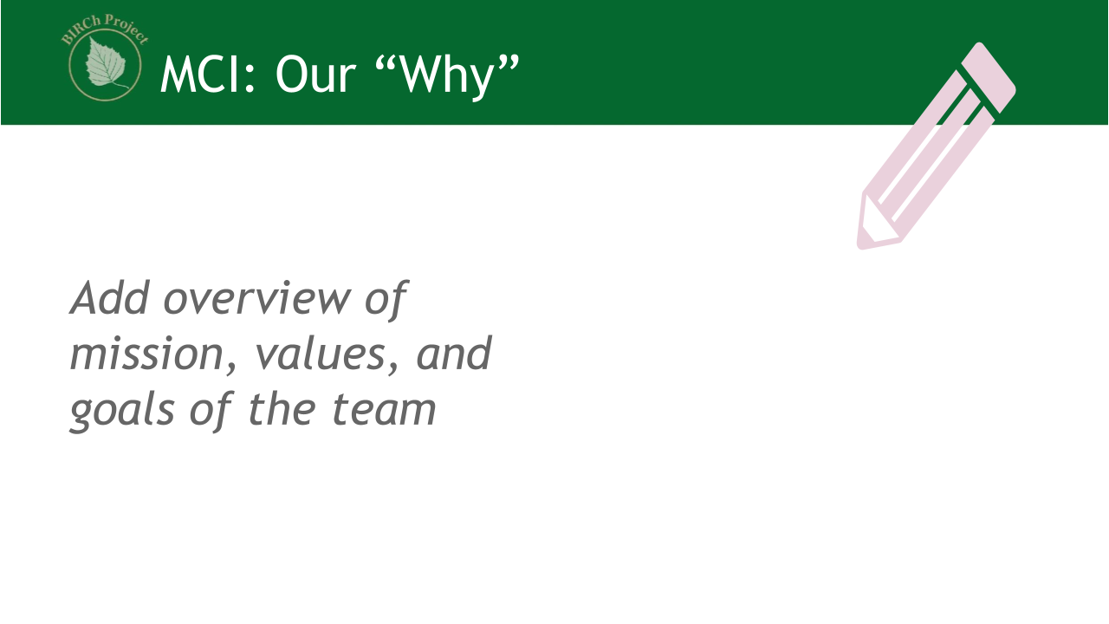

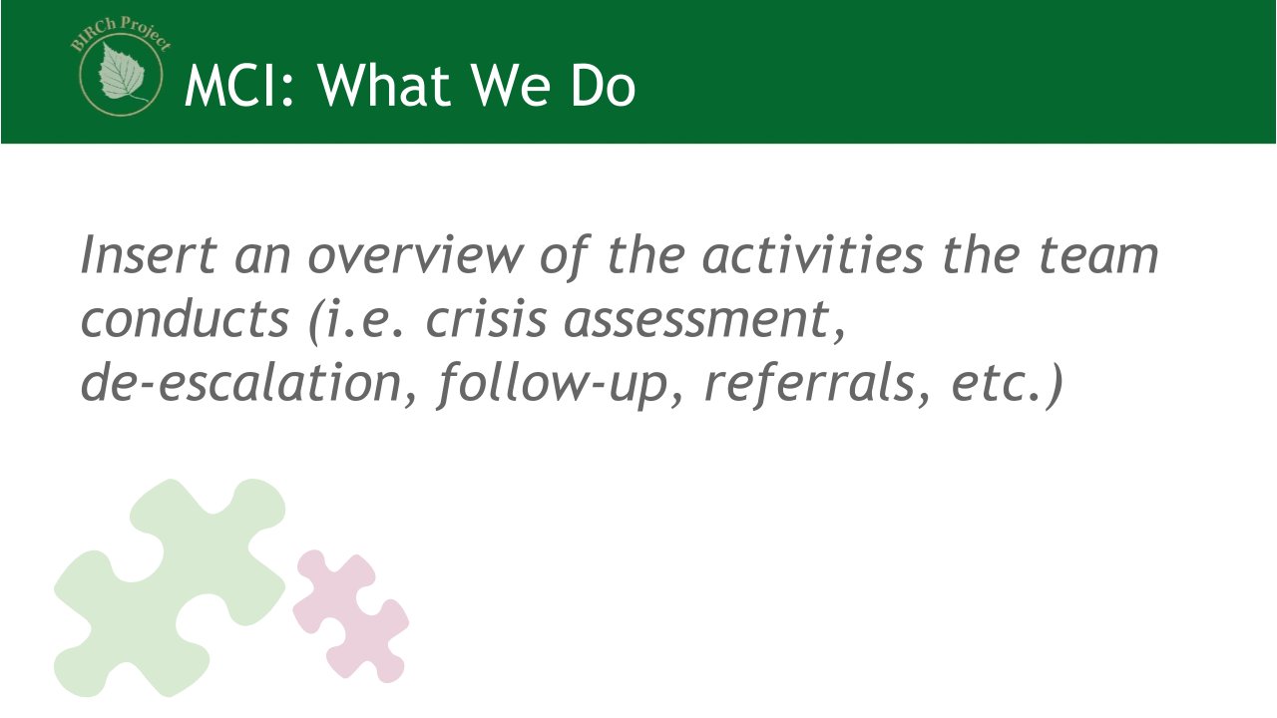

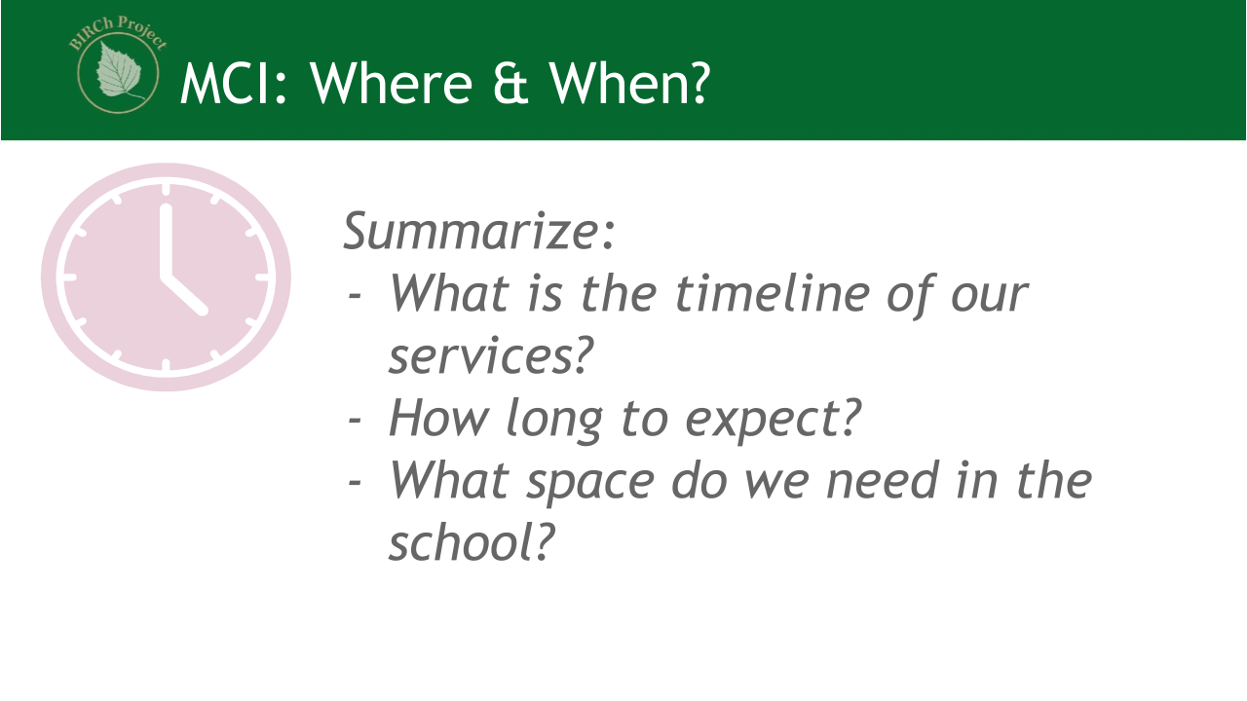

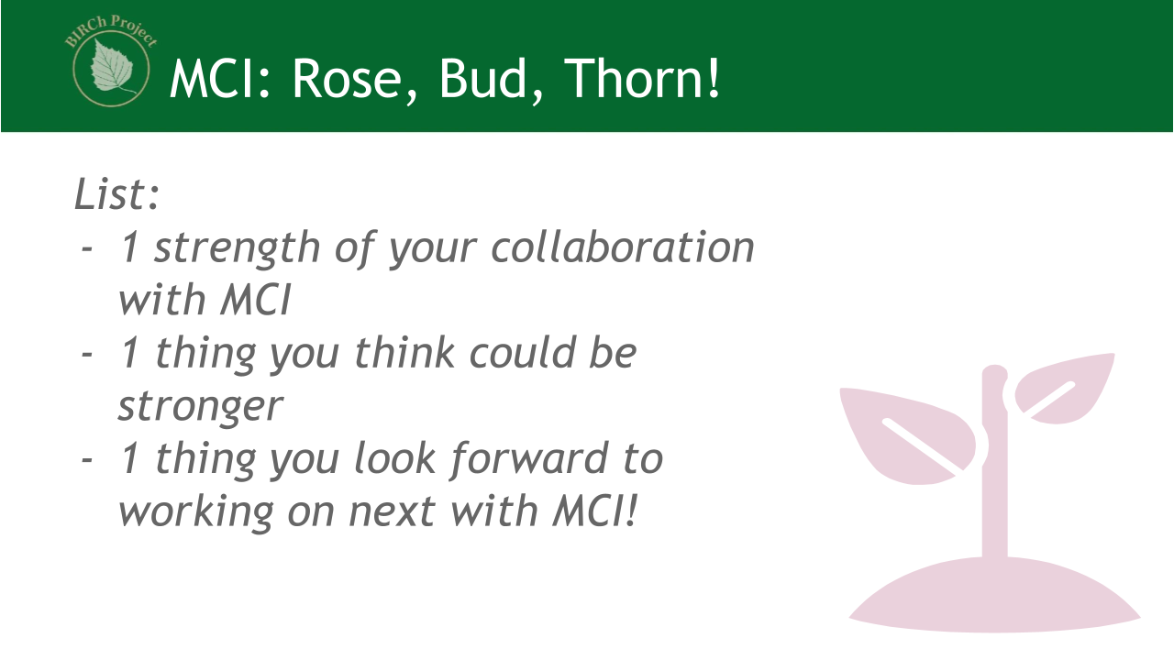

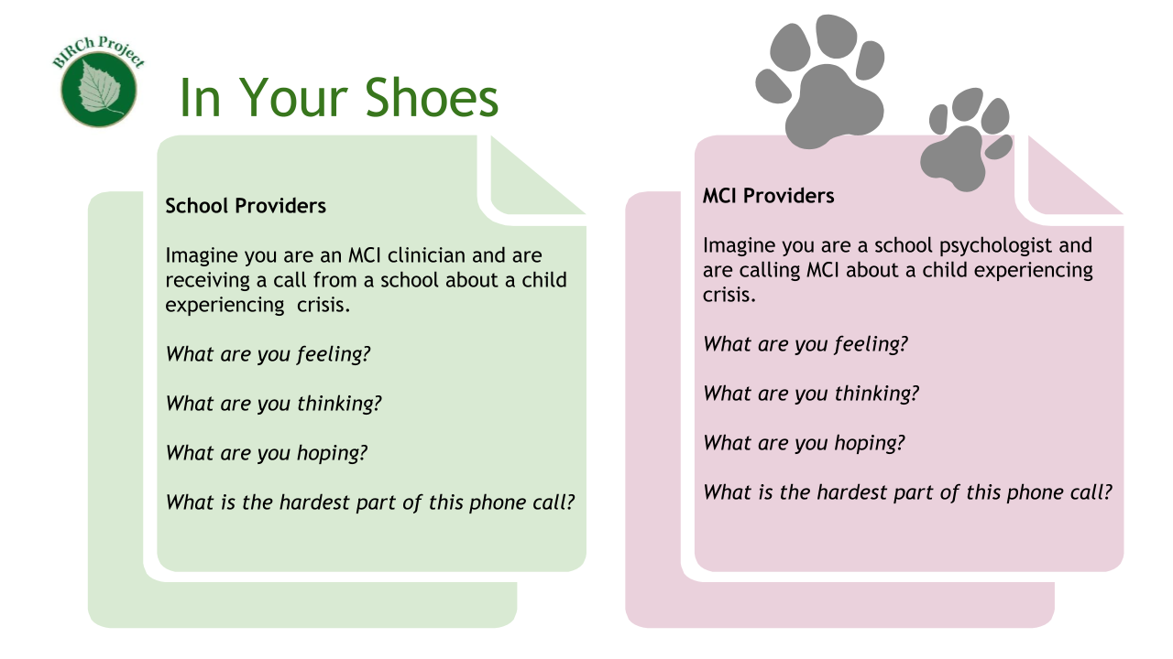

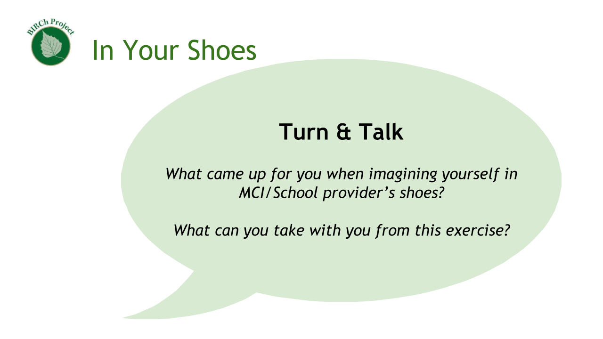

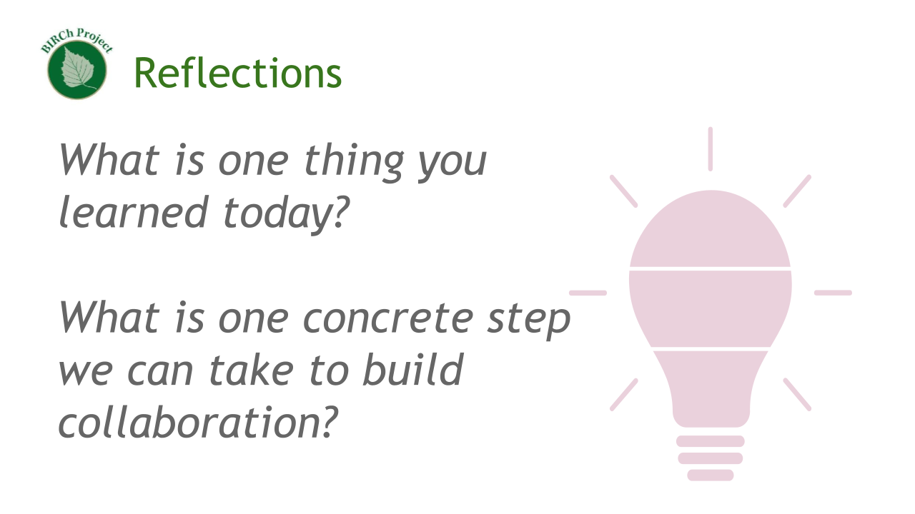

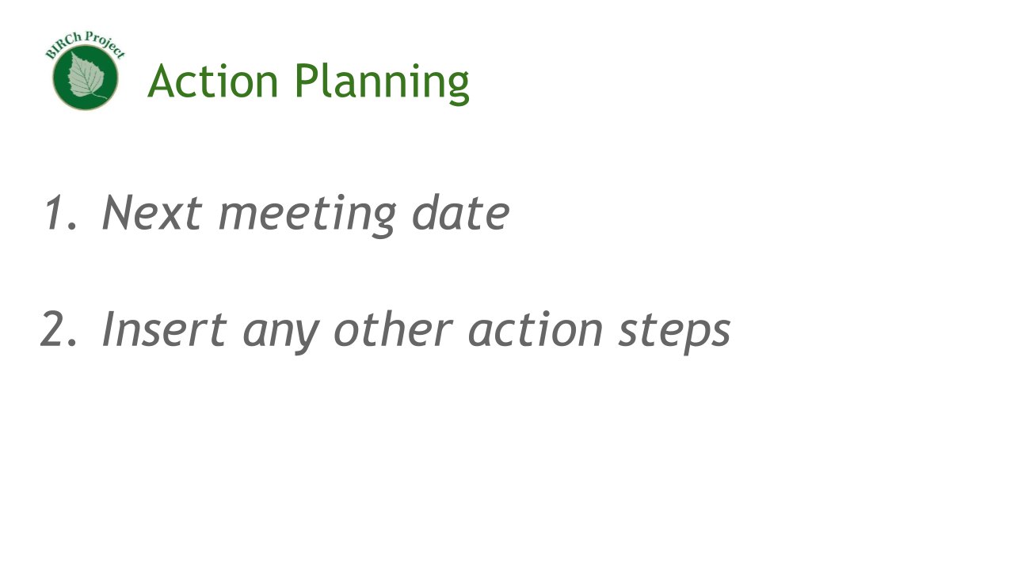

## Inter-Agency Contact & Information Sheets

The documents in this section include samples and blank fillables to foster the collaborative process between schools and MCI providers. They can be completed collaboratively and shared with relevant school and community providers to foster a shared language and identify points of contact so everyone knows who to contact in a crisis.

**SAMPLE - MCI Information for Schools**

**Central Mobile Crisis Team**

*Information for Schools*

|  |  |  |
| --- | --- | --- |
| **Contact Information** | | |
| **Address:**  Central Mobile Crisis Team  1 Main Street, Greenville MA, 01234  **24/7 crisis line:**  111-222-3333 | **Emergency Services Program Director:**  Jane Smith  222-333-4444  janesmith@central.org  **Mobile Crisis Intervention Director:**  Manuel Gomez  333-444-5555  manuelgomez@central.org | **Responding Family Partners:**  Carlos  Sarah  Miriam  Zahara  **Responding Clinicians:**  Alison  Fabiola  Mohammed |
| **Overview of Mobile Crisis Intervention** | | |
| *Mobile Crisis Intervention Teams provide mobile, short term, in-person, therapeutic response to youth experiencing a behavioral health crisis for the purpose of identifying, assessing, treating, and stabilizing the situation and reducing immediate risk of danger. MCI services are designed to be delivered through the systems-friendly, wraparound process of engaging the family, convening the team, developing the plan, implementing the plan, and transitioning the youth to the appropriate level of care. The wraparound process should incorporate a plan that is designed to be culturally competent, strengths based, and organized around family members' own perceptions of needs, goals, and likelihood of success of specific strategies.* | | |
| **What?** | MCI services include assessment, tele consultation with psychiatrist, family partner services, crisis planning, collateral contacts, crisis intervention support for up to 7 days, transition planning, intensive case management as needed, de-escalation, etc. The responding team will include a family partner and a trained clinician. | |
| **Who?** | We serve all youth in MA experiencing a behavioral health crisis. While extended MCI is only available for students with MassHealth and other select insurance plans, the team will provide crisis intervention for any youth in need. | |
| **When?** | Our crisis line is active 24/7 and we will respond at any time. While we aim to respond within 60 minutes, keep in mind that response times vary due to high demands. If the crisis occurs near the end of a school day, someone from the school must stay to support. Always call 911 if immediate help is needed. We also provide follow-up services after a crisis. | |
| **Where?** | We respond on-site at school, home, or wherever the youth is experiencing a crisis. When we respond at school, we will need a private place to conduct our evaluation. | |
| **Why?** | MCI can connect youth and families with needed community-based resources, support school staff in crisis response, and can prevent unnecessary emergency room use. To find out more about the many benefits of MCI services, visit the following website: <https://www.mass.gov/childrens-behavioral-health-initiative-cbhi> | |

**FILLABLE (feel free to copy language from sample!)**

**MCI: ___________**

*Information for Schools*

|  |  |  |
| --- | --- | --- |
| **Contact Information** | | |
| **Address:**  **24/7 crisis line:** | **Emergency Services Program Director:**  **Mobile Crisis Intervention Director:** | **Responding Family Partners:**  **Responding Clinicians:** |
| **Overview of Mobile Crisis Intervention** | | |
|  | | |
| **What?** |  | |
| **Who?** |  | |
| **When?** |  | |
| **Where?** |  | |
| **Why?** |  | |

Adapted from CBHI MCI practice guidelines (Appendix E)

**SAMPLE - School Crisis Information for MCI**

**Central School Crisis Team**

*Information for Mobile Crisis Intervention*

|  |  |  |
| --- | --- | --- |
| **Contact Information** | | |
| **Address:**  Central School Crisis Team  1 Main Street, Greenville MA, 01234  **Front Office:**  111-222-3333 | **School Psychologist (contact first):**  Jane Smith  222-333-4444  janesmith@central.org  **Principal:**  Manuel Gomez  333-444-5555  manuelgomez@central.org | **Other crisis team members:**  Carlos (nurse)  Sarah (social worker)  Miriam (BCBA)  Zahara (assistant principal) |
| **Overview of Central School Crisis Team** | | |
| *As part of our school and district crisis plan, we have a team responsible for responding to behavioral health crises. Our approach is grounded within our multi-tiered system of support, which includes universal, targeted, and crisis intervention for all students with and without special education services. When responding to crises we partner with the student, family, and outpatient providers to ensure comprehensive and integrated support.* | | |
| **What?** | We use a data and team based problem solving model to identify students in need, provide support, monitor progress, and evaluate impact and next steps.  *Assessment:*  In crisis situations, the school psychologist is responsible for evaluating student safety and developing an action plan which may include a call to MCI. The school psychologist also oversees progress monitoring and any further assessment needed upon returning to school. If the school psychologist is unavailable or out of the building, the school nurse would be the next school staff responsible for evaluating the student. If the school nurse is unavailable, contact district Behavioral Health Services at ____________________ for back up.  (phone # for your district here)  *Interventions:*  We provide social, emotional, and behavioral interventions to students with and without IEPs. Students are referred to our Student Support Team to evaluate if and when this is necessary. More informal check-ins for social, emotional, and behavioral wellness are also available as needed. In crisis situations, our clinicians support students to cope and de-escalate in the moment. They work with students and families to create and implement safety plans.  *Care coordination and referrals:*  We work with community-based clinicians and organizations to ensure comprehensive and integrated support of all students. When needed, we can refer students and families to outpatient providers for regular and longer-term support beyond what is available within the school. | |
| **Who?** | Our school crisis team includes the nurse, social worker, BCBA, assistant principal, school psychologist, and principal. We work closely with teachers, families, and other educators as needed. Please direct communication to the school psychologist and the school nurse. | |
| **When?** | We respond to any crisis during the school day. For crises occurring outside of the school day, we provide re-entry and follow-up support. We meet regularly as a team on Wednesdays at 1pm to review student cases, and we welcome any MCI providers to join us virtually or in person. | |
| **Where?** | While we respond to student crises anywhere in the building, we typically conduct assessment and intervention in the school psychologist’s or school nurse’s office if the school psychologist is unavailable. Due to having so many students, sometimes it is difficult for us to identify a private space to meet but we continue to work on ensuring our students and providers have confidential, adequate space to meet. | |
| **Why?** | As educators and school professionals we have the unique experience of seeing students every day within their natural environment and often have existing relationships with families. We can provide counseling services, check-ins, other social emotional interventions, and can decide as a team to refer for special education evaluation when necessary. | |

**FILLABLE (feel free to copy language from sample!)**

**School:________**

*Information for Mobile Crisis Intervention*

|  |  |  |
| --- | --- | --- |
| **Contact Information** | | |
| **Address:**  **Front Office:** | **Contact First:**  **Principal:** | **Other crisis team members:** |
| **Overview of School Team** | | |
|  | | |
| **What?** |  | |
| **Who?** |  | |
| **When?** |  | |
| **Where?** |  | |
| **Why?** |  | |

## Sample Emergency Contact Form

***Instructions:*** Please use this contact form as needed. It is intended to be completed collaboratively.

|  |  |  |  |  |  |  |
| --- | --- | --- | --- | --- | --- | --- |
| **Student Name:**  **Student Date of Birth:**  **School Name:**  **Grade:** | | | | | | |
| **Family Section** | | | | | | |
| *Primary Contact Information:* | | | | | | |
| **Name** | **Relationship to Student** | **Cell Phone Number and Home Phone Number** | **Email Address** | **Availability**  *Day or night* | **Does this person have a signed release?** | **What Information Should be Shared?** |
|  |  |  |  |  | * Yes * No | * Medical * Academic * Mental Health * 504 Plan * IEP |
| *Secondary Contact Information:* | | | | | |  |
| **Name** | **Relationship to Student** | **Cell Phone Number and Home Phone Number** | **Email Address** | **Availability**  *Day or night* | **Does this person have a signed release?** | **What Information Should be Shared?** |
|  |  |  |  |  | * Yes * No | * Medical * Academic * Mental Health * 504 Plan * IEP |
| *Tertiary Contact Information:* | | | | | |  |
| **Name** | **Relationship to Student** | **Cell Phone Number and Home Phone Number** | **Email Address** | **Availability**  *Day or night* | **Does this person have a signed release?** | **What Information Should be Shared?** |
|  |  |  |  |  | * Yes * No | * Medical * Academic * Mental Health * 504 Plan * IEP |
| **School Section** | | | | | | |
| *Primary Contact Information:* | | | | | | |
| **Name** | **Role** | **Telephone Number** | **Email Address** | **Availability** | **Is this individual crisis trained?** | |
|  |  |  |  |  | * Yes * No   Date: | |
| *Secondary Contact Information:* | | | | | | |
| **Name** | **Role** | **Telephone Number** | **Email Address** | **Availability** | **Is this individual crisis trained?** | |
|  |  |  |  |  | * Yes * No   Date: | |
| *Tertiary Contact Information:* | | | | | | |
| **Name** | **Role** | **Telephone Number** | **Email Address** | **Availability** | **Is this individual crisis trained?** | |
|  |  |  |  |  | * Yes * No   Date: | |
| **MCI Section** | | | | | | |
| *Local Crisis Contact* | | | | | | |
| **Agency** | **Region** | **Address** | **Contact Person Name**  *if available* | **Operating Hours** | **Does the agency have access to a safety plan for the student?** | |
|  |  |  |  |  | * Yes * No | |
| *Secondary Contact* | | | | | | |
| **Agency** | **Region** | **Address** | **Contact Person Name**  *if available* | **Operating Hours** | **Does the agency have access to a safety plan for the student?** | |
|  |  |  |  |  | * Yes * No | |
| **24/7 MCI Number: 1-877-382-1609**  ***Call will be automatically transferred to the closest Emergency Services Program/Mobile Crisis Intervention.*** | | | | | | |

## Caregiver-School-MCI Communication Guidelines

**Purpose:** When a student is in crisis, it is imperative that all providers (schools, mobile crisis, families) are on the same page about the crisis plan. For this to occur, communication must occur in three stages: pre-crisis, during crisis, post crisis. Strong communication allows for collaboration, clarity, safety, trust, and empathy for all parties involved. It encourages strength-based support and family centered approaches. Please ensure these protocols are in line with your school district’s crisis and safety plan.

**General Considerations:**

*Crisis can be an emotionally-driven and stressful time for all parties involved. Please remember to approach one another with kindness and to remember that each person is responsible for a piece of supporting the youth. All actions are in the youth’s best interest. The youth’s safety is the priority.*

* Communication is from a culturally sensitive, trauma informed lens
* Family-driven communication is in the families native language, or the family has known English proficiency
* Student strengths are communicated frequently with families and family voice is prioritized
* Limit the use of acronyms to ensure common language and family friendly language to prevent misunderstandings
* Screen and protect the youth from unnecessary adult conversation



# Pre-Crisis

* Procedure Before Calling MCI
* Preparing Materials & Space for Crisis
* Teaming, Roles, & Responsibilities
* Communication Guidelines

## Procedure Before Calling MCI

Pre-crisis procedures refer to the planning and preparation stages of MCI and school collaboration. Take the following into consideration when formulating your own team plan:

|  |
| --- |
| **BEFORE Calling MCI: Summary** |
| * Identify whether the student presents as at risk for harming themselves or someone else; assess for safety using existing school/district procedures.   + If there is an immediate safety threat, call 9-1-1. Follow school procedures for contacting 9-1-1.   + If symptoms can be managed and there is no immediate safety threat, review the student’s safety plan to ensure all steps have been followed, consider the student’s history of previous unsafe behavior to self or others. Work with the student’s school based team (i.e. nurse, guidance counselor, etc.) to de-escalate and provide support. Consider contacting parent/guardian and any outside providers to update.   + If no immediate safety threat but symptoms are more acute than can be managed in the school setting (including implementation of the student’s IEP, behavior plan, and safety plan, de-escalation strategies, etc.) consider if MCI is an appropriate response. |

|  |
| --- |
| **BEFORE Calling MCI: More Details…** |
| * **DO NOT LEAVE THE STUDENT ALONE** * Protect the student’s confidentiality and dignity: find a private space if you are not already meeting with the student in a private space. * Decide as a team what your next steps should be (see ESP and MCI Service Location Decision Tree). * *If the student, family, or others are at imminent threat of harm, serious injury, overdose, or health condition requiring immediate medical attention, call 9-1-1 and notify the guardian as soon as possible.* * Determine how to let others know that you will be unavailable for your daily schedule for a period of time (meetings with students, staff, etc.) * Determine how to let teachers know the student is unavailable for next classes so the student is not marked with an unexcused absence for the class. * Consider the time of day, MCI is not on the school day schedule, so someone needs to be there, consider if MCI should respond in the home or community or school. |

## Preparing Materials & Space for Crisis

Prepare these materials for students who have already been identified as at-risk or students who have experienced crisis in the past. Some of these materials will be helpful for any student in crisis:

* This protocol
* Related school crisis protocols and procedures
* Tools to help de-escalate student, materials for student to calm while waiting for MCI (e.g., sensory tools, fidgets, tools student uses to cope with urge to self-harm)
* Student’s relevant records: available to share with other providers if consent is given
* Student’s IEP
* [Student’s safety plan](https://www.masspartnership.com/pdf/CBHI_Safety_PlanFinal.pdf)
* Student’s emergency contact information
* Student’s current providers’ contact information
* Blank ‘consent to exchange information’ forms
* Private, confidential place
* Access to computer, phone
* Bottled water, snacks, gum or mints

## Teaming, Roles and Responsibilities

**Team*:*** *Always use a team-based, equity-driven, and trauma-informed approach for decision making regarding when to call MCI. Partner with the family in this process. The goal is appropriate utilization of MCI, being careful not to over or under identify students of various cultural, economic, gender, racial, linguistic, and ethnic backgrounds. Making decisions as a team enables more effective and informed action planning at vulnerable decision points. The team responsible for calling and collaborating with MCI may be the same team used for other student support processes (i.e. IST, SST, etc.). Below is a sample team composition:*

* Crisis Team Leader
* Crisis Team Co-Leader or Assistant Leader
* MCI Communication Liaison (point of contact and a back up if that person is absent)
* Family/Guardian Communication Liaison
* Student support personnel (can be one team member or alternating team members that have a strong relationship with the student)
* Regulation support staff
* Medical support staff
* Principal
* Assistant principal and/or dean(s)
* School psychologist(s)
* School social worker(s) and/or school adjustment counselor(s)
* Special education teachers
* School nurse(s)
* School Therapeutic Support Staff (Applied Behavior Analysis (ABA) specialists, outside agency therapists)
* Interpreter/translator

**Point personnel:** *There should be a point person in the school for the following roles: 1) coordinating with MCI in general (including determining the ideal chain of events when a call is made to MCI), 2) calling the guardian, 3) determining which staff need to know what about the crisis, 4) acting as point of contact for MCI while on school grounds, 5) following up with MCI, the student, and family, 6) remaining at school after dismissal and making sure the child gets home safely, and 7) back up for if any of these people are absent that day (note: these responsibilities may fall to a single person or any number of people).*

**Roles:** *While anyone may make a call to MCI at any time (including parents and other community providers), there should be a process within the school for determining the ideal person to make that call within the school context (i.e. principal, school psychologist, etc.). For example, the role of the classroom teacher may be to refer concerns to the principal, who in consultation with the school psychologist, will call MCI.*

## Communication Guidelines

|  |  |  |
| --- | --- | --- |
| **Pre Crisis** | | |
| **Families** | **Schools** | **MCI** |
| * [Complete contact sheet](https://docs.google.com/document/d/1Bc833-671k6iygc7cZ2dKjZ4yWESthOVneWm4zaTerw/edit) * [Complete this form to communicate your preferences for treatment](https://docs.google.com/document/d/1_TOmSznKMjCKK8Byz5cFbhQKuHtDNdJcf5ced2pWxvM/edit) * Communicate prior medical and mental health history, including your personal experiences with these services * Communicate youth’s prior educational experience * Communicate your cultural beliefs about mental health * Identify any current mental/behavioral health supports in place * More resources can be found at:   + [A Parent & Caregiver Guide to Helping Your Family Before, During, and After a Crisis: The Baker Center-English Version](https://www.bakercenter.org/resources/library/a-parent-caregiver-guide-to-helping-your-family-before-during-and-after-a-crisis)   + [Click here for Spanish Version](https://www.bakercenter.org/resources/library/a-parent-caregiver-guide-to-helping-your-family-before-during-and-after-a-crisis-en-espanol) | * School establishes the school-based point person (and a back up contact if that person is unavailable) for all communication * [Complete contact sheet](https://docs.google.com/document/d/1Bc833-671k6iygc7cZ2dKjZ4yWESthOVneWm4zaTerw/edit) * Set up a partnership meeting withMCI * Schedule a meeting to listen and reflect on the families personal experiences * Review the Family Questionnaire * Complete a clear safety plan for the child with the child, family and MCI (if MCI is already involved), while incorporating family strengths * Develop an internal [script](https://docs.google.com/document/d/1wqR3zn4PFgBAqfpPy-irrQ7NarWQfQjeyWH85EtjS3s/edit) and send it to the district attorney for review. This script can be used during a crisis incident to contact the family. * Decide which team member will hold the following roles during a crisis: * Be with the student * Contact MCI * Contact the family * Be responsible for re-entry * Communicate with MCI to see if any paperwork can be completed in advance on behalf of a student | * Facilitate a school training (powerpoint) in the local school systems that is open to school officials, community partners and families * Set up a partnership meeting with schools * Establish a point person for all communication per school * Communicate with local school districts regularly about any changes/updates to protocols * Ensure the local school systems have an active list of MCI clinicians and providers with their updated emails and telephone numbers * Review the Family Questionnaires |

# 

# 

# 

# 

# 

# During Crisis

* Encounter with MCI
* School to Family Communication Script
* Communication Guidelines

## Encounter with MCI

**IF the team has consulted and decided that contacting MCI is the best course of action:**

|  |
| --- |
| **Encounter with MCI: Summary** |
| * Notify the team that MCI will be called * Prepare all materials and space needed for collaborating with MCI (i.e. review this document, etc.). * Contact guardian to collaborate and obtain consent for contacting MCI   + If guardian is reached and provides verbal consent to contact MCI     - Contact MCI     - [Support student while waiting for MCI](https://docs.google.com/document/d/1gHuTtrqifMy_ky3HQJCMsVKYKmOuPuMpgp5egp6YRJo/edit#bookmark=id.jzuf4zsw6jkb)     - Engage in deescalation, assessment, and planning with student, caregiver, and MCI     - Debrief and document following the crisis   + If the guardian cannot be reached, contact emergency contacts of the child to help get in touch with the guardian. If the guardian cannot be reached in a reasonable amount of time (will depend on your particular situation: needs of the student, history of previous difficulties, time of the day), continue to try contacting the guardian and also call MCI. |

|  |  |  |
| --- | --- | --- |
| **Encounter with MCI: More Details…** | | |
| **Calling MCI** | | |
| **Decision Point** | **School Roles/Responsibilities** | **MCI Roles/Responsibilities** |
| Contact guardian to collaborate and obtain consent for contacting MCI | Contact the student’s guardian to obtain verbal consent to contact MCI as identified on their emergency contact form to obtain consent BEFORE contacting MCI. If they do not pick up, leave a message and try contacting the student’s other emergency contacts listed.  See [script](https://docs.google.com/document/d/1wqR3zn4PFgBAqfpPy-irrQ7NarWQfQjeyWH85EtjS3s/edit) for suggestions on language to use in contacting families.  If emergency contacts cannot be reached, contact MCI and continue to contact the guardian.  Let the main office know that a parent or guardian may be coming to the main office and to contact you when they arrive. Share that the family is dealing with a sensitive issue, remind them to protect the student’s confidentiality, and encourage them to be especially warm in their greeting.  See [Communication Guidelines](https://docs.google.com/document/d/1I6pfnsJeY4ONyVg3L48Of2bTG8yfNuZo6Mjev_wQTds/edit) | N/A |
| Contact MCI | When calling MCI, be sure to have the following information handy: student’s name, date of birth, address, caregiver names and phone numbers, social security number (if available).  See [Communication Guidelines](https://docs.google.com/document/d/1I6pfnsJeY4ONyVg3L48Of2bTG8yfNuZo6Mjev_wQTds/edit) | When receiving a call from schools, remember the staff member may have a range of experience with crises (from none to extensive). They are calling MCI because they feel they have exhausted all avenues of support within the school setting.  See [Communication Guidelines](https://docs.google.com/document/d/1I6pfnsJeY4ONyVg3L48Of2bTG8yfNuZo6Mjev_wQTds/edit) |
| **Waiting for MCI** | | |
| **Decision Point** | **School Roles/Responsibilities** | **MCI Roles/Responsibilities** |
| Support student while waiting for MCI | Let the main office staff know you are going to let the MCI providers in through the closest door to where you are meeting with the student.  Do not leave the student alone.  Be realistic about wait time and be prepared to use a range of de-escalation strategies throughout the wait. | Be realistic about wait time and communicate openly and honestly with school providers.  Advise staff as needed about what they can do in the interim to support student and family and MCI efforts. |
| **Working with MCI** | | |
| **Decision Point** | **School Roles/Responsibilities** | **MCI Roles/Responsibilities** |
| Engage in deescalation, assessment, and planning with student, caregiver, and MCI | Someone needs to be available after school hours.  Care for guardian/caregiver throughout the MCI assessment. | Advise how school-based crisis responders and law enforcement can approach the student. |

## School to Family Communication Script

Utilize your contact sheet to see who to call.

*Reminder: your call will likely evoke emotion within the parent. Validate their feelings and reassure them of the policy in place. Keep a calm tone of voice. Stick to the observable behaviors the child demonstrated. Focus on safety as the priority and teamwork.*

**Script :**

Hello, (*parent name*). My name is (*your name*) from (*school name*) district. I am (*define role at school*). I am calling you because (student name) is having unsafe behavior today. We have tried [*describe the interventions you implemented including those in place in the child’s safety plan and IEP if they have those supports but they have been unsuccessful for X amount of time*]. Our priority is to keep your child safe today and we need more support to do so. We have a plan in place for this. We think your child would benefit from us contacting Mobile Crisis Intervention. Are you familiar with Mobile Crisis/has your child/family used MCI in the past?

We are calling to get your consent to contact MCI and to work together to make sure your child and family are supported in this process. You know your child best and your partnership is so important to us. Are there questions I can answer that would be helpful before you decide if you provide your consent for us to contact MCI? Do you consent to us calling MCI? We will keep you updated throughout this process but can you also come to school to meet with MCI and us at school to make a plan for next steps? If you don’t provide your consent, can you come to school to meet with us to make a plan for next steps in supporting your child’s safety?

OR

We understand you may be at work or dealing with other responsibilities, we’ve been unable to reach you so the school team called a mobile crisis team for support. Can you come to school to meet with MCI and us at school to make a plan for next steps?

*Describe where the child is currently: child is being brought to (hospital name) with (staff name). Child is waiting in the principal’s office with (staff name) for a mobile crisis team member to arrive.*

You can reach me at (provide your contact information). Again, my name is (*X*) and I am the (*X*) at school. If I am unavailable, you can contact X at school. We will figure this out together with your help!

|  |  |
| --- | --- |
| **Parent says** | **School Response** |
| *What did my child do?* | Describe specific observable behavior in a factual manner. Do not include extraneous details or make hypotheses about what could be happening.  𐄂 “Xavier is displaying psychotic behaviors.”  ✓ “Xavier says he is hearing voices and appears disoriented.” |
| *What can I expect next?* | The Mobile Crisis Team will come and assess your child in order to determine next steps. They are professionals trained in mental health. If you are able, you can come to the school and be present for the assessment. We can notify you if they recommend that your child be sent to the hospital before you arrive. |
| *I don’t provide my consent for MCI and I can’t come to school to pick up my child.* | I’m sure this is a really overwhelming time. We continue to be concerned about being able to keep your child safe at school. We will continue to try to de-escalate your child and keep them safe. Are there any of the child’s emergency contacts that can come pick them up at school? If your child continues to escalate and we feel we cannot keep them safe, we will need to contact school/community law enforcement to support. When we do that, school staff and caregivers shift decision-making to law enforcement to decide how to proceed. We will provide our input but they take over with making final decisions for how to proceed. |
| *How much does MCI cost?* | More insurance companies cover certain behavioral health services for children. We encourage you to contact your child’s insurance company to learn more about what is covered under their insurance plan.  https://ppal.net/general-information/ |
| *Are you going to call DCF?* | Like you, our goal and legal responsibility is to make sure your child is safe. We want to do that by working together as a team. Our goal is not to call DCF. All school staff are mandated reporters which means we are legally mandated to contact DCF if we suspect your child is at-risk of being abused or neglected in any setting. |
| *Can I come to the school now?* | Encourage the parent to meet the child wherever they currently are. Ensure them that if anything changes before they are able to get there, you will notify them as soon as possible. |
| *Did you put hands on my child?* | Describe the safety care training used in the incident. Let them know that physical restraints are only utilized when staff determine that a student is at imminent risk of harming themself or others. |
| *MCI hasn’t helped before so why are you calling again now?* | That sounds so frustrating and stressful. We know we have a lot of work to do in this state to make sure there are appropriate, helpful, and needed mental health services for kids. We are hoping that this time we contact MCI we will be able to all work together to explore additional community supports and they can provide guidance to us at school about how best to support your child. |

## Communication Guidelines

|  |  |  |
| --- | --- | --- |
| **During Crisis** | | |
| **Families** | **Schools** | **MCI** |
| Review the [Family Questionnaire](https://docs.google.com/document/d/1_TOmSznKMjCKK8Byz5cFbhQKuHtDNdJcf5ced2pWxvM/edit) question 6 “What do you need to take care of before the child goes to mobile crisis (*other children, pets, spouse, your parents, neighbors, ect)*?”  Go to destination to meet your child/student  Continuously give updates to the point person at the school while waiting | Point person reviews the Family Questionnaire  Point person calls MCI and faxes over the contact sheet, Family Questionnaire to MCI  Call MCI to ensure forms are received and record a contact persons name at MCI  Point person contacts the family to begin communication (refers to the developed [script](https://docs.google.com/document/d/1wqR3zn4PFgBAqfpPy-irrQ7NarWQfQjeyWH85EtjS3s/edit))  If child is still at school, point person waits for the family’s arrival with the student’s belongings  Reflective listening is used when communicating with one another.  ***Example:***   * *With student: “*What I am hearing is that you are upset you cannot go to recess right now. Do I have that right?” * *With Family:* “I understand that you feel nervous about these next steps. We are trained to handle these crises. Please use me as a contact during this time. I will keep you informed.” * *With MCI:* “What I hear you saying is that the child is safe to return to school tomorrow.”   Nonverbal communication should remain neutral with student  ***Example:***   * *posture, facial expressions, proximity*   Provide student with distractions.  ***Example:***   * “I know you have a dog named Molly. What kind of dog is Molly?”   One school team member should take the lead in communication with student. This team member should:   * Be familiar to the student * Be familiar with safety protocol (district and individual) * Be aware of student’s history (medical/mental health) and special education status   One school team member should be communicating with other students or teachers in the environment  ***Example:***   * Relocating other students to new room using a calm voice   Clear, short, positive, calm phrases/expectations are used when communicating with students. Only present one demand at a time or two options  ***Example****:*   * “Stand up”, “calm body” * First/then language * “Would you like to stand or sit?”   Prewarn student in crisis of next step  ***Example:***   * “We are going to ride the ambulance together now. I will be here for you.” * “Your aunt Lisa is on the way here to help you.”   Communicate a helpful tip (if possible) to MCI about the student  ***Example:***   * Favorite game, family pets, favorite color   Point person continues to reach out to family during the crisis.Point person communicates to internal school crisis team to update them during the crisis | Point person receives the call and reviews the faxed documents from the school. This information is communicated to the crisis team that's working with the student.  MCI point person ensures they write down the school contact persons name and number  MCI point person contacts the school contact person when the student arrives and begins their assessment  Reflective listening is used when communicating with one another.  Nonverbal communication should remain neutral  ***Example:***   * *posture, facial expressions, proximity*   Provide student with distractions.  ***Example:***   * *“*Your teacher told me you love cars. What type of cars do you like?”   MCI contact person provides a brief update to school contact person and family during evaluation process |



# Post-Crisis

* Following up with MCI
* Post Crisis Reflection
* Family Questionnaire
* Communication Guidelines

## Following up with MCI

|  |  |  |
| --- | --- | --- |
| **Following up with MCI** | | |
| **Decision Point** | **School Roles/Responsibilities** | **MCI Roles/Responsibilities** |
| Debrief and document following the crisis | Guidelines for following up with Mobile Crisis, as well as internal follow up within the school and following up with the family and student:  Determine who needs to know about the crisis and in what level of detail, next steps with treatment planning (e.g., interventions at school, links to community supports), remind team about MCI point of contact at school and a backup if that person is absent.  Documentation - who is responsible for documenting the encounter with Mobile Crisis? What kind of documentation? Frame documentation/data tracking as a matter of equity. Documentation/data can be broad, without sacrificing student confidentiality.  Students with and without IEP and 504 plans may benefit from MCI. Students with and without IEP and 504 plans may also receive short-term behavioral health support within the school setting (i.e. behavior support plan, counseling, etc.). Following the crisis, all providers and caregivers, along with the student, should discuss both general and special education support available to the student. | Follow MCI documentation guidelines.  Discuss and consider with the student and guardian what information would be helpful for school behavioral health staff to be aware of. Inform student and guardian how access to this information could strengthen support of the student throughout the school day. |

## Post-Crisis Reflection

**Instruction:**

Please take a moment and briefly reflect on your experience as a team member. Consider the following “buckets” when debriefing personally and debriefing with your team. Please include both strengths and areas of improvement. Please also reflect on your own role in this exchange. Feedback from all team members will help improve our communication and future responses.

|  |  |
| --- | --- |
| **Time**   * *How was the response time?* * *Do you feel other providers valued your time?* * *Were other providers understanding of timing limitations? How were these communicated about?* |  |
| **Interactions**   * *Did you feel you were listened to by the other parties?* * *Did you feel this process was collaborative?* * *Was communication in your native language/in words that you understand?* * *Was communication student strength based family driven?* * *Did you feel other team members were empathetic in their interactions? Were you empathetic?* |  |
| **Feasibility**   * *Do you have the resources to implement the suggested interventions? If not, can you obtain these easily? Do you know how to obtain the resources necessary?* * *In the future, are there additional actions school/MCI team members could take next time to make your response more feasible?* |  |
| **Follow Through**   * *Were you provided with explicit directions for next steps?* * *Do you feel supported?* * *Do you know who you can go to (point person) to discuss this further?* * *Is there anything school/MCI team members can do to help facilitate stronger follow through?* |  |

## Family Questionnaire

This questionnaire is a non-legal document that allows you to communicate directly with your provider. Complete this questionnaire to prepare for a future crisis and following a crisis situation. You know your child the best. The first section of this document should be filled out in collaboration with your child to communicate their wants and needs. The second section of this document should be completed by you. Upon completion, this form will be shared with the school system’s crisis team and the mobile crisis team. This form can be updated at any time. Please include any communication needs and/or cultural practices that are important to you.

**Child Name: DOB:**

|  |
| --- |
| **Child Section** |
| 1. When I am in a crisis I feel… 2. When I am in a crisis I need… 3. I know I am about to have a crisis when… 4. When I am in a crisis, I do **not** like when people… 5. When I am in a crisis, I prefer to talk to… 6. When I am in a crisis, it helps when…   *Anything else you’d like to share:* |

|  |
| --- |
| **Family Section** |
| 1. How do you know that your child is experiencing a crisis? (*please include what they may look like, what they may say, or what they may be doing)* 2. What strategy has been most helpful for your child during a crisis? What is **NOT** helpful for your child? 3. What is an important thing for the school to know when my child is having a crisis? 4. What is an important thing for the mobile crisis team to know when my child is having a crisis? 5. Do you know when your child is more likely to have a crisis (*do you see it coming? how?)* 6. What do you need to take care of before the child goes to mobile crisis (*other children, pets, spouse, your parents, neighbors, ect)*? 7. What type of follow-up would be helpful for you and your family after the crisis?   *Anything else you’d like to share:* |

Which staff at the school are you comfortable sharing this information with?

**Signature of Family:**

**Signature of Child:**

Date Initially Completed:

Date(s) Revised: Revision 1:__________ Revision 2: _________ Revision 3: _________

|  |  |  |
| --- | --- | --- |
| **Staff that Reviewed Document** | | |
| **Name** | **Date** | **Original or Revised** |
|  |  |  |
|  |  |  |
|  |  |  |

*Adapted from the Guidelines for Individuals/Families for Completing an “Advance Communication to Treatment Provider” document*

## Communication Guidelines

|  |  |  |
| --- | --- | --- |
| **Post Crisis** | | |
| **Families** | **Schools** | **MCI** |
| * After receiving the outcome of the evaluation, prepare accordingly.   ***Example:***   * *If child is to return home, ensure increased supervision at home and communicate changes in behavior/mood during scheduled check-in with MCI and the school* * *If the child requires inpatient support, ensure your own supports are in place regarding child care for other children, pets, etc and be available for constant communication* * Reach out to contact the school point person to debrief and update them on the outcome of the MCI assessment * Reach out to your MCI point person for additional clinical services and supports * [Share](https://docs.google.com/document/d/1FZacQeXEYO-X3GF4ZYpoQSJhbpP02vKNNzDDY_PXZnQ/edit) your experience with the school about how school and MCI handled the experience * Remain open to new suggestions and interventions by team members (school and MCI) | * School point person calls the MCI point person to get results from the student’s crisis assessment * School point person arranges a team meeting to make a plan for the student’s transition back to school based on MCI assessment * *Considering incorporating family communication such as a daily behavior report card or log into the student’s reentry plan* * Revisit or create a safety plan to address the recent crisis * A referral for a Functional Behavior Assessment is considered, if not already in place (the process is described to the parent in detail and consent is generated) * [Reflect](https://docs.google.com/document/d/1FZacQeXEYO-X3GF4ZYpoQSJhbpP02vKNNzDDY_PXZnQ/edit) on your experience and talk about what went well/what needs improvement/what you needed more of from MCI/where were there breakdowns in communication? * Remain open to new suggestions and interventions by team members (family and MCI) | * The MCI team communicates the results of the crisis assessment to the family * The MCI team communicates the results of the assessment to the school point person and that person shares the results with entire school crisis team at the team meeting * Recommendations are made regarding reentry into school after the crisis event based on their evaluation. * [Reflect](https://docs.google.com/document/d/1FZacQeXEYO-X3GF4ZYpoQSJhbpP02vKNNzDDY_PXZnQ/edit) on your experience and talk about what went well/what needs improvement/what you needed from school * Remain open to new suggestions and interventions by team members (school and family) |

# 

# Please provide feedback on this toolkit:

<https://forms.gle/8Da1ZmNspN9tpAv49>

We look forward to hearing from you!

# Suggested Resources

***Massachusetts Specific:***

[Boston Area Behavioral Health Resources Guide](https://sites.google.com/bu.edu/babh-resource-guide/home)

[Designated Community Mental Health Centers](https://www.mass.gov/info-details/community-behavioral-health-centers)

[CBHI Brochures & Companion Guide](https://www.mass.gov/service-details/cbhi-brochures-and-companion-guide)

[CBH Knowledge Center](https://www.cbhknowledge.center/)

[Motivational Interviewing for Everyday Families](https://handholdma.org/what-can-i-do/the-school-of-hard-talks-online-lessons-from-motivational-interviewing-for-everyday-families)

[Special Education Parents Advisory Councils (SEPAC)](https://www.spedchildmass.com/special-education-sepac-massachusetts/) *(parent support groups available)*

[CBHI Mobile Crisis Intervention Practice Guidelines](https://www.mass.gov/doc/mobile-crisis-intervention-practice-guidelines-0/download)

[MBHP ESP Statewide Directory](https://www.masspartnership.com/pdf/MBHPESPDirectory.pdf)

[MassHealth: A Guide for Staff Who Work with Children, Youths, & Families](https://www.mass.gov/doc/masshealth-behavioral-health-services-for-children-and-youth-aged-20-and-younger-a-guide-for/download)

[MassHealth School Personnel Resource Guide](https://www.mass.gov/doc/school-personnel-resource-guide/download)

[Wellness & Recovery After Psychosis (WRAP)](https://www.bmc.org/wellness-and-recovery-after-psychosis-wrap/wrap-without-walls#:~:text=What%20is%20WRAP%20Without%20Walls,substance%20use%20and%20psychosis%20symptoms.)

[MassHealth as a Secondary Insurer](https://www.mass.gov/info-details/masshealth-and-private-health-insurance-also-known-as-third-party-liability-tpl)

[How to Enroll in MassHealth (as both primary and secondary insurance)](https://www.mass.gov/how-to/enroll-in-a-masshealth-health-plan-individuals-and-families-younger-than-65)

***General:***

[National School Boards Association: Fostering Safer Schools](https://www.nsba.org/-/media/NSBA/File/legal-fostering-safe-schools-guide.pdf)

[National Education Association’s School Crisis Guide](https://www.nea.org/sites/default/files/2020-07/NEA%20School%20Crisis%20Guide%202018.pdf)

[Guide for Developing High Quality School Emergency Operations Plans](https://rems.ed.gov/docs/School_Guide_508C.pdf)

[The Role of Districts in Developing High Quality School Emergency Operations Plans](https://rems.ed.gov/docs/District_Guide_508C.pdf)

[SAMHSA National Guidelines for Behavioral Health Crisis Care](https://www.samhsa.gov/sites/default/files/national-guidelines-for-behavioral-health-crisis-care-02242020.pdf)

[NASMHPD: Improving the Child & Adolescent Crisis System](https://www.nasmhpd.org/sites/default/files/2020paper9.pdf)

[Strategies for De-escalating Student Behavior in the Classroom](https://assets-global.website-files.com/5d3725188825e071f1670246/632ccb7a3756f3529d3a7391_Strategies%20for%20De-escalating%20Student%20Behavior%20in%20the%20Classroom.pdf)

# References

Alvarado, G., Hegg, L., & Rhodes, K. (2020). Improving Psychiatric Access for Students

in Crisis: An Alternative to the Emergency Department. *Psychiatric Services*, 71(8), 864–867.<https://doi.org/10.1176/appi.ps.201900195>

Blader, J. C. (2004). Symptom, Family, and Service Predictors of Children’s Psychiatric

Rehospitalization Within One Year of Discharge. *Journal of the American Academy of Child & Adolescent Psychiatry,* 43(4), 440–451.<https://doi.org/10.1097/00004583-200404000-00010>

Blader, J. C. (2011). Acute Inpatient Care for Psychiatric Disorders in the United

States, 1996 Through 2007. *JAMA Psychiatry,* 68(12), 1276–1283.

<https://doi.org/10.1001/archgenpsychiatry.2011.84>

Bradshaw, C. P., Buckley, J. A., & Ialongo, N. S. (2008). School-based service

utilization among urban children with early onset educational and mental

health problems: The squeaky wheel phenomenon. *School Psychology*

*Quarterly*, 23, 169–186.<http://dx.doi.org/10.1037/1045-3830.23.2.169>

Caldarella, P., Young, E. L., Richardson, M. J., Young, B. J., & Young, K. R. (2008).

Validation of the Systematic Screening for Behavioral Disorders in middle and junior high school. *Journal of Emotional and Behavioral Disorders*, 16, 105 – 117. [https://doi.org/10.1177/1063426607313121](https://psycnet.apa.org/doi/10.1177/1063426607313121)

Case, B. G., Olfson, M., Marcus, S. C., & Siegel, C. (2007). Trends in the inpatient

mental health treatment of children and adolescents in US community hospitals

between 1990 and 2000. *Archives of General Psychiatry*, 64(1), 89–96.<https://doi.org/10.1001/archpsyc.64.1.89>

Crepeau-Hobson, F. (2013). An exploratory study of suicide risk assesment practices in

the School setting. *Psychology in the Schools*, 50: 810-822.<https://doi.org/10.1002/pits.21705>

Fendrich, M., Kurz, B., Ives, M., & Becker, J. (2018). *Evaluation of Connecticut's*

*Mobile Crisis Intervention Services: Impact on Behavioral Health Emergency*

*Department Use and Provider Perspectives on Strengths and Challenges*. Farmington, CT: Child Health and Development Institute of Connecticut, Inc.

Goldsmith, L. J. (2021). Using Framework Analysis in Applied Qualitative Research.

*The Qualitative Report*, 26(6), 2061-2076. <https://doi.org/10.46743/2160-3715/2021.5011>

Judge Baker Children’s Center (n.d.). *A parent and caregiver’s guide to helping your*

*family before, during, and after a crisis*. <https://www.bakercenter.org/application/files/5416/4640/7062/family_crisis_guide.pdf>

Kalb, L. G., Stapp, E. K., Ballard, E. D., Holingue, C., Keefer, A., & Riley, A. (2019).

Trends in Psychiatric Emergency Department Visits Among Youth and Young Adults in the US. *Pediatrics*, *143*(4), e20182192. <https://doi.org/10.1542/peds.2018-2192>

Kessler, R. C., Berglund, P., Demler, O., Jin, R., Merikangas, K. R., & Walters, E. E.

(2005). Lifetime prevalence and age-of-onset distributions of DSM-IV disorders

in the National Comorbidity Survey Replication. *Archives of general psychiatry*, 62(6), 593–602.<https://doi.org/10.1001/archpsyc.62.6.593>

Krass P, Dalton E, Doupnik SK, Esposito J. US Pediatric Emergency Department Visits

For Mental Health Conditions During the COVID-19 Pandemic. *JAMA Netw Open*.

2021;4(4):e218533. doi:10.1001/jamanetworkopen.2021.8533

Leeb, R. T., Bitsko, R. H., Radhakrishnan, L., Martinez, P., Njai, R., & Holland, K. M.

(2020). Mental Health–Related Emergency Department Visits Among Children Aged <18 Years During the COVID-19 Pandemic—United States, January 1–October 17, 2020. *MMWR. Morbidity and Mortality Weekly Report*, *69*(45), 1675–1680.<https://doi.org/10.15585/mmwr.mm6945a3>

Martin, W. (2005). *An efficacy study of a youth mobile crisis intervention program*.

(Unpublished doctoral dissertation). Union Institute and University, Cincinnati, Ohio.

Shannahan, R., Fields, S. (2016). *Services in Support of Community Living for Youth with Serious Behavioral Health Challenges: Mobile Crisis Response and Stabilization Services.* National Technical Assistance Network for Children’s Behavioral Health, U.S. Department of Health and Human Services, Substance Abuse and Mental Health Services Administration. <https://theinstitute.umaryland.edu/media/ssw/institute/national-center-documents/Mobile-Crisis-Response-&-Stabilization-Services-May-2016.pdf>

Soto, E. C., Frederickson, A. M., Trivedi, H., Le, A., Eugene, M. C., Shekher, M., Weiskopf, M., Allen-Dicker, K., Dicker, R., Fornari, V., & Correll, C. U. (2009). Frequency and correlates of inappropriate pediatric psychiatric emergency room visits. *The Journal of clinical psychiatry*, *70*(8), 1164–1177. <https://doi.org/10.4088/JCP.08m04839>

Training and Access Project, Boston Children's Hospital Neighborhood Partnerships

(2021). Managing behavioral health crises in school [online lecture].<https://www.childrenshospital.org/programs/boston-childrens-hospital-neighborhood-partnerships-program/tap-online-trainings>

Zealberg, J. J., Santos, A. B., & Fisher, R. K. (1993). Benefits of mobile crisis programs. *Psychiatric Services*, *44*(1), 16-17